Wilfrid’s War

Preface

In telling the story of my grandfather’s World War One experience, I decided to go beyond his personal experience, which, while interesting from a family-history point of view, would be richer aif merged with a larger narrative of Canadian military history of that time.

Wilfrid’s active-service letters – written from his entry into battle in April 1916 to his wounding and conveyance back to England to recover in early October of that same year – clearly convey the evolving trauma of his life in the trenches, and, along with that, a growing bitterness and somewhat disturbing – if inevitable -- blunting of emotion. The letters themselves, especially those written during Wilfrid’s active service at Ypres and the Somme, could only relate a small part of his experience of war. Wilfrid had to be careful that his letters only focused on private and family matters. Military censors (regimental officers) reviewed every letter from the field prior to its posting to ensure no mention was made of troop location or operational details of specific military activities that could prove of value to the enemy. Forbidden information included references to locations, numbers of troops, criticism of superiors and even the weather (which might indicate the state of the trenches).

In recent years, a large amount of information about Canadian military operations during World War One has become public knowledge. Of particular interest are the records in the form of daily entries by battalion, brigade and divisional leaders into official war diaries. Documenting the events of each day – which would include the numbers of those killed and wounded, the enemy action behind that carnage and specific details of retaliation efforts – was an important leadership task at the battalion and brigade levels. At the Division level, we find operational and strategic papers, as well as diary entries by divisional commanders (i.e., generals).

I’ve included this wider perspective of larger troop movements and operations, and daily trench-level activity to provide a more complete and accurate picture of Wilfrid’s experience than the letters alone could provide.

I also to decided to include details about the fate and experience of a few other Neepawa men, who had been friends and neighbours of Wilfrid’s that he mentions in the letters, in order to more broadly capture the impact of the war. Neepawa itself was hit hard by the war. In 1911, its population was 1,800 and it lost 120 men over the course of WW1. The population had grown by 400 by 1941, but only 73 men died during WW2. I include stories of Wilfrid’s friends who died, were more seriously wounded or suffered from acute trench-related disease.

I’ve also included a discussion of and out-takes from the letters of Wilfrid’s best friend (and surrogate brother), Richard Buckley.

A Note on the Scanned Letters

I’ve been careful to scan every letter Wilfrid wrote with only a few rare exceptions: I did not scan only a handful of letters that were addressed to either his sister May or his mother, Nellie, if they contained identical information. I also didn’t scan any letter written of legal-sized paper that begins at the top of the page (only one so far) because that size of paper simply doesn’t fit on my scanner.

Many of the letters, particularly those written on the battlefield, were written in pencil and under duress, so they’re not all that legible. I’ve tried to remedy this by tweaking them with the software editing tools available with my scanner. These tools increase the contrast or fill in faded lines with additional pixels. In some cases, it much easier to read the scanned letters than the originals.

When Wilfrid was declared unfit for active military service and took up full-time clerical work in for the Canadian Casualty Assembly Centre (C.C.A.C.) in Folkestone (January, 1917), he starts to type many of his letters on office stationery. His letters become more detailed, thoughtful and voluble, as well as much more legible at this point. He appears to have been a natural-born typist and expressed himself more freely and volubly when freed from the labor of writing with pen or pencil. And, of course, he no longer had to worry about his letters being closely reviewed by officer censors either.

Wilfrid Dunlop, a 23 year-old clerk from Neepawa, enlisted to serve in the Canadian Expeditionary Force on August 9th, 1915 at the Winnipeg Recruiting Office.

Wilfrid appears to have been officially known both as Wilfred and Wilfrid. Even his best friend, Richard Buckley consistently referred to him as Wilfred in all his letters, and, clearly he had to fight his whole life to be called Wilfrid instead of Wilfred. Here, I’ll refer to him by the name he preferred. Wilfrid chose to spell his Christian name in the English style, perhaps in imitation of Wilfrid Laurier, the dominant Canadian politician of the era, much admired by Wilfrid. During the war, Laurier was the leader of the Liberal party in Canada, and he fiercely opposed conscription, as did Wilfrid.

This is the story of Wilfrid’s war, but it was hardly a unique experience. Like many other young Canadian men, he may have tried to enlist at the outbreak of the war but not been accepted until 1915. Enthusiasm for joining up in the opening days of the war in August of 1914 was incredibly high in Canada, and many more young men attempted to enlist than could be processed and accommodated. Within a month of the 1914 recruitment call for 20,000 volunteers, nearly twice that number had signed up, and the military were forced to suspend enrollment. It’s interesting to note that over twice the number of Neepawa men enlisted for the first world as for the second. Diminished love of empire certainly played a part, but the bitterness and disillusionment experienced by everyone after WW1 no doubt played the lead role.

Colonial Anglophilia and love of empire were powerful forces in a population that was either born in the U.K. or were first-generation Canadians. It’s estimated that at the outbreak of WW1, there were over one-million British-born citizens in Canada who retained a strong loyalty to their mother country. And, for the Canadian born, the romantic notion of taking part in heroic battles on the world stage while defending the civilized world from an evil aggressor was just too strong to withstand.

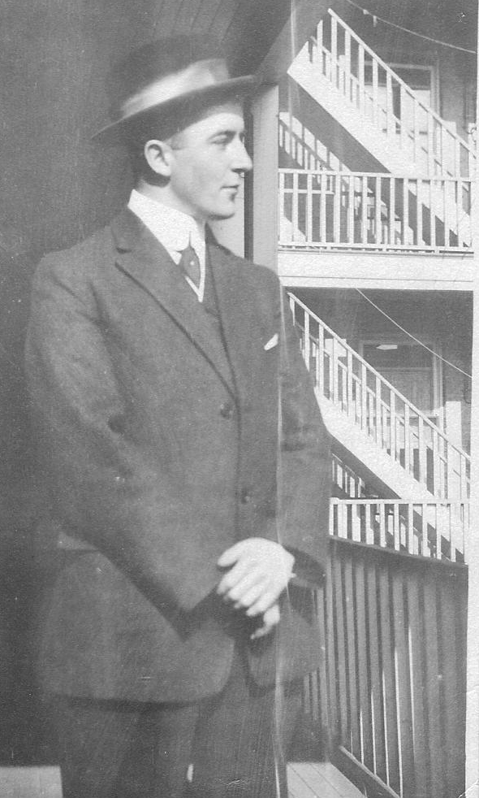Wilfrid Pre-WW1

Wilfrid’s earliest letters from Belgium, before war-weariness and bitterness set it, often refer to his disbelief that he was part of something so large and important. The life of a young clerk living in a small-town backwater of a country that was itself a backwater must’ve seemed awfully dull in comparison to the good vs. evil struggle that was consuming the entire civilized word. Also, much more personally and closer to home, it provided Wilfrid with an opportunity to redeem himself in the eyes of a skeptical family that considered him a good-time Charlie, lacking in ambition and perhaps in moral fibre and “character”, too.

To a 23-year-old clerk living in a small town in one of Canada’s least interesting provinces, it would be a compelling opportunity to launch himself onto the world stage – and in the process redeem him in the eyes of a father who had long favored his older, more serious and more educated brother, Blake.

Wilfrid and his friend Richard joined the 78th battalion (Winnipeg Grenadiers) of the second contingent of the Canadian Expeditionary Force – which had become an urgently needed as reinforcements for the first contingent, the ranks of which had been depleted by participation in the major battles of 1915 -- the second battle of Ypres, Gravestafel, St. Julien and Festubert.

Richard and Wilfrid were sent to Camp Sewell, near Carbery, Manitoba. His letter from the training camp reflect a tough, “very strenuous” rather spartan existence that was hard “for one who is used to easy times” in Neepawa.

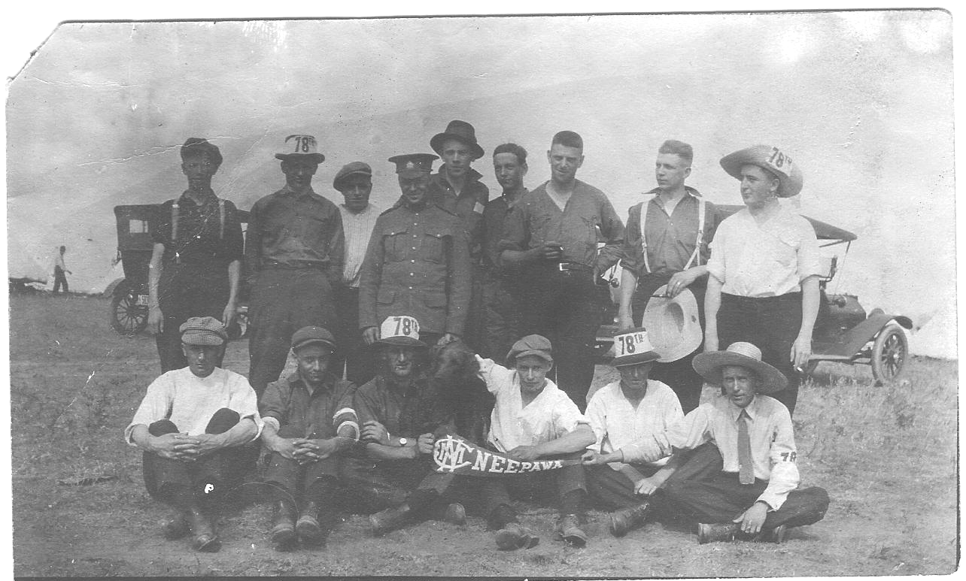
Check Out the Portly Kid in the Cowboy Hat!
Wilfrid’s Training Unit at Camp Sewell (Carbery, Manitoba)

Wilfrid looks relaxed and happy in the training-camp photo, sporting his 78th Battalion cowboy hat while smoking a cigarette with apparent ease and confidence. He’s clearly the only overweight recruit in the group, training must have been difficult indeed for a clerk used to an exclusively sedentary life.

According to Leona Dunlop, Wilfred really enjoyed the good things in life, from dressing well to eating well, and, while he doesn’t directly complain about the quality of the food when he wrote to his mother, he did allow as how “one boy in our battalion dropped dead yesterday while drilling, partly on account of the heat and to a certain extent through lack of proper nourishment.” He added, “since then they have been serving us better meals.”

The constant drilling in the fierce heat of a Manitoba August and September finally came to an end in mid-September. He traveled by train and foot marches to Quebec, and thoroughly enjoyed the trip. It was his first experience of really seeing vast stretches of the country from west to east. “It is a wonderful country,” he concluded, “and it seems a shame to leave it.”

The first leg of the trip was to Winnipeg, where he had a half-hour stopover. He wired his sister May and her husband, Bill, and they drove to station for the last visit with family that Wilfrid would enjoy for nearly five years. He was closer to his two sisters and his mother than to his brother and father. Although we don’t know for sure, the family story was that Alexander Dunlop never once wrote to his son either before, during or after his stint of active duty – and vice versa. Wilfrid wrote freely and often to his mother and sisters, and seems to have had a very close relationship with them all.

At 5 a.m. on September 25th, Wilfred set sail from Montreal on a massive ship called the S.S. Corsican.

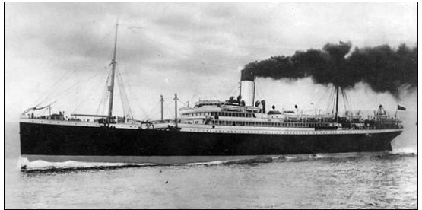
Despite its Mediterranean name, the Corsican was an Irish passenger ship that had been seconded by the Canadian government to assist in the first-ever conveyance of an entire country’s militia across the Atlantic to support the allied effort to vanquish German aggression. Like most trans-Atlantic passenger ships of that period, it had been used to transport U.K. and European emigrants to North America. It had a large steerage section on the bottom deck that could accommodate 1500 steerage (third class) passengers in the bowels of the ship, and 400 second class and 200 first class passengers on the upper decks.

Wilfrid was assigned to join the 32nd reserve battalion, as a second-wave of reinforcements to replace those who had already died at the front.

He gave his family his address as follows:
Pte. W.L. Dunlop Reg. # 148158
78th Reinforcements,
32nd Reserve Battalion,
Risboro Barracks,
Shorncliffe, Kent, England.

He resides at Shorncliffe for many months, not actually leaving for France until March 15, 2016, when he was assigned to join the 5th battalion of the 2nd brigade, Canada’s First CEF division. Training was a boring routine of marching and drilling, the longest marches being 15 miles long (often at night after a day of drilling) wearing his full pack. In most of the letters from this long training period (October to March) his tone is weary from physical tiredness and also from the unending dreariness of training: “All I have time to do here is eat, sleep and work”. His letters from this period focus on his homesickness and pleas for more letters, an ongoing need for cash (requests were almost always addressed to his sister, May, rather than his mother) and the rigors and hardships of “range” training. He seems genuinely impatient to get to the front.

In early January he was offered a job “on headquarter staff” but turned it down. “I have gone this far with soldiering and I am going to see it through.” His evident clerical and typing skills made him an obvious office asset, and, throughout the majority of his time overseas, the army clearly prized his skill with a typewriter over his “soldiering”, keeping him in medical records rather than moving him back to France. Many of his buddies were also wounded, but they ended up going back to the front lines – even before they were fully restored – and, as a result, many of them died or were horribly wounded. While he was thrilled not to have to return to the trenches after his leg injury sent him to “blighty”, he also clearly felt like he had been permanently sidelined by the high value assigned to his clerical prowess – and this rankled somewhat, but not enough to ask to be sent back into the action.

By this time, he had moved from Shorncliffe to billets in Lyminge, Kent, about 5 miles from Folkestone and the English channel. The first billet was a little rough but the second billet, to which he was moved later in January, was “an elegant place” where “the people are very nice” and “they surely do feed us good.” In the same letter that announced the new billet, he described “a severe jolt” in the form of a government decree that all those serving in the Canadian military would have their pay reduced by one-half:

The balance is kept for us by the government and when we return from the war it will be given to us. It sounds pretty fishy to me. If we don't come back, the government keeps it. Some graft!

On January 24th, Wilfrid was informed he had to return to Shorncliffe barracks to take advanced training in “trench digging, bomb throwing and bayoneting”, and wait for the formal draft announcement. It was to be a fairly long wait of about six weeks. He came close to being sent earlier but some odd happenstance consistently prevented it from happening. Apparently, you had to respond to the draft in person to qualify, and once he was one duty away from the base and another time a superior officer, who would not qualify to fight in the trenches, requested to be reverted in rank so he could go – and he took Wilfrid’s draft place.

Finally, on Tuesday, March 14th, he went to France. When his name was called to sail to the front lines, his tone is nearly jubilant – which is not surprising given how long he’d been cooling his heels in England. The dull repetitive nature of the seemingly endless training maneovres and duties certainly played its part, but Wilfrid seemed more than relieved, he seemed positively buoyant.

His optimism and relief are clearly expressed in the March 4th letter to his mother:

I am mighty glad of the change, although it means harder work and all that but I am feeling fine and am not worrying about what is to come. I am going to do my best and only hope that I will be lucky enough to come through it all. Don’t worry about me. I will be alright and will write each week as usual.

Finally, this small-town Canadian boy was about to step onto the world stage and take part in the largest conflict in history. On a grimmer note, he is clearly aware of the central part that luck will play in enhancing his chances for survival.

In his letter to his sister May on March 11th, he states that he’s “delighted with the prospective change and am fit and ready for what may come.” In this letter he doesn’t mention luck, though, he says, “it all remains with myself now.” He waxes a little more emotional when he writes to May; and we note again that he’s much less straightforward in his letters to her and more reflective . He says:

I am feeling fine...and am taking good care of myself. I cannot afford to abuse my constitution in any way as I will need all my wits about me when I go to the trenches, and, believe me, I am going in to the thing with all my heart and soul. I have a chance now to make up for some of my follies and I tend to take advantage of the opportunity.

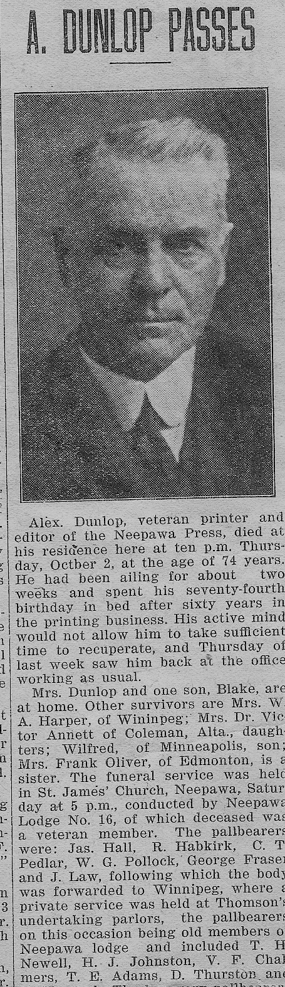
It’s clear that the war was, for Wilfrid as for many others, an opportunity to redeem a misspent youth and an accumulation of “follies” in the eyes of his family and his town. He could show them that he was made of the same stern stuff as his father and that Victorian generation of hard-working, unrelentingly joyless pioneers.

In almost every letter to May, Wilfrid alludes to a debt that she is actively paying down for him from his pay:

When we are warned for draft I am going to renew that assignment to you at the rate of $25.00 per month. As soon as you have Glass paid up you can start sending me cigarettes with the money.

At that time a lack of frugality signalled serious defects of character. To have amassed debts at this young age of 24 certainly suggest he was living beyond his means and this, coupled with a lack of discipline, seriousness and ambition (he stated his calling as “clerk”) would not have sat well with a family that was known for high-minded rectitude and industry.

His father, Alexander, was a driven, ambitious man, the founder and publisher of the Neepawa Free Press, a highly regarded pillar of the small-town society of Neepawa.

When Alexander died, two months after the birth of Wilfrid’s twin sons, Bill and Bob, a front-page obituary praised him for his vigor, industry, morale purpose and dedication to progress. Alexander’s newspaper, The Neepawa Free Press, begun 34 years before, had made a huge impact on his community (“no-one did more for his community”). His energy and industry paid off with recognition: In 1921, the paper was awarded the prize as the best published weekly in Western Canada.

He was a Liberal party stalwart and “held offices in local organization, and gave his time and strength without reserve for the public welfare….he will be remembered as one of the best citizens of the province.” He was a member of the Canadian and Manitoba Press Associations, the International Order of Odd Fellows, and the Anglican church. He served on the Neepawa town council and played lacross with the Winnipeg Lacrosse Club.

Alexander was a self-made man, who had strong beliefs about the value of community service, who would brook no fault, flaw or laxity in “civic management” and would pursue perceived corruption or wrong-doing in a “pugnaciously aggressive” manner in his newspaper. This was not a father who would easily forgive a son’s moral transgressions.

Nor was he what we would call today a hands-on father. Rumor has it that Wilfrid never once received a letter from his “papa” Alexander, and while he mentions him occasionally in early letters, his name does not appear often for the remaining years of Wilfrid’s military service. The only time Wilfrid mentions anything like a fond fatherly reprimand, it was his brother, Blake, to whom he refers. I suspect Blake, who was 11 years older than Wilfrid, was a warmer and more constant father figure to Wilfrid than Alexander.

In an amusing postscript to a letter written to Nellie a month after he was wounded at Courcelette, Wilfrid explains that the hospital in which he’s being treated (the Newcastle General Hospital) had previously been the “old Newcastle Work House. “Do you remember whenever I used to buck at hoeing potatoes or moving the lawn how Blake used to say that “some of these days you will end up in a work house.” Well, here I am. His words came true.” His son Robert would often suggest that our family in Calgary might end up in a work house, as well, so those words clearly became part of the Dunlop family lore.

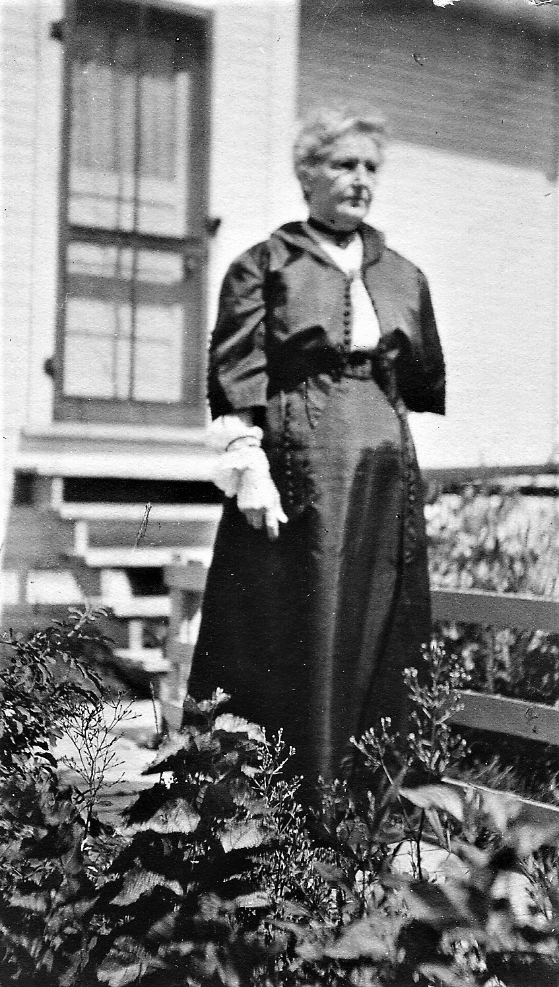
One suspects the Dunlop household in Neepawa was not especially tolerant of laziness or weakness. In a letter to Wilfrid’s mother from Risboro barracks (one of the Canadian barracks in the Shorncliffe training camp near Norfolk), Wilfrid’s best friend, Richard Buckley, mentions that he and Wilfrid regularly attended a Sunday evening choral concert in the nearby village, and added this comment: “It may seem a wicked way to spend our Sundays, but one might do much worse.” This suggests that the Dunlop household was a strict one. Even in 1916, strict religious observances were breaking down. The Roaring Twenties and the age of jazz that followed the Great War didn’t emerge from a vacuum. The Dunlops, however, were staunch C. of E. and likely frowned on hedonism --- or at any activity that violated Victorian convention.

Alexander was a man of outspoken, high-minded principles, and it’s not surprising that he appears to have disowned Wilfrid for his “follies” and his pleasure-loving ways, while grooming his eldest son to take over as publisher of his beloved paper. It’s interesting to note that when Wilfrid did finally return from England in 1919, he more or less left directly for Minneapolis. His discharge papers state that he wanted to work as a salesman in Toronto upon his return to Canada, but Toronto was likely just as job-poor as Winnipeg.

Just like after any other war, there were precious few jobs for the returning veterans, and fierce competition for those. Minneapolis was a boomtown in the 1920s, and many fortunes were made in lumber and wheat-milling. General Mills, then known as Washburn-Crosby, was headquarted there,

He returned to Neepawa for a short time to act as the business manager for the paper, but only after his father had died. Blake was printer and executive editor and Wilfrid was the manager, but this relationship didn’t last long, and by 1932, Wilfrid had moved to Winnipeg to work as a government clerk.

Family lore (as related to me by Wilfred’s son, Robert, has it that Alexander did not once write to his son throughout the duration of the war. His eldest son, Blake, was groomed and raised as the successor to the business, and Wilfred had nothing to do with it at all until Alexander’s death in 1930 (just one month after the birth of Wilfred’s twin boys, Bob and Bill.

Wilfred was clearly viewed as the morally weak black sheep, dissolute and maybe irredeemable. According to his wife, Leona, my grandmother, he loved to dress well and was a clothes horse. If his military record is to be believed, Wilfred also enjoyed drinking (he was charged twice with “being drunk in the high street.” While we don’t have anything much to go on beyond his own acknowledgement of his “follies” and the ongoing struggle to pay off a large debt to a certain Mr. Glass, and a marred military record, Wilfrid had clearly out of favor with the old man.

Early Days in the Trenches with the Fifth Battalion

Wilfrid had joined the 5th Battalion, as a part of the Canadian First Division, in the southern portion of the Ypres salient, which had long been a proudly Canadian sector of the front line. While he had missed some terrible offensives, the fighting of the year 1916 is, by general agreement of WW1 historians, among the bitterest of the whole war – and the Ypres salient was one a major focus of German offensive efforts. The first heavy fighting for the Canadians was in April around the Craters of St. Eloi, in the same southern sector of the salient occupied by the 1st Division.

This sector has been much fought over. Huge underground mines had been detonated; the ground had been churned up by shell-fire; and the rains had made it a quagmire. It was in this sector that Wilfrid got his first taste of trench warfare, and a rough initiation it turned out to be.

Wilfrid’s early letters from the front are full of enthusiasm for a “thrilling life” and, to his mother, he’s fulsome in his praise for how well the British look after their colonial brothers-in-arms. He is “well fed and well equipped...wanting for nothing. It certainly makes a fellow feel good when he realizes all that is being done for him and his comfort. I am better satisfied over here than I have been since I enlisted.”

The first week of his service in France was dry and sunny – “elegant” weather as he described it to his mother. By the way, “elegant” was always Wilfrid’s go-to highest superlative. But trench life turned wet, cold and miserable soon enough.

Wilfrid was lucky to be introduced to trench life during a period of relative calm between major formal battles. The battalion to which he had become attached – D Company, 2nd brigade of the fifth battalion, was part of the 1st Canadian Division. The 1st Division had been involved in most of the major British offensives from 1915 onwards.

What Wilfrid Missed

I915 had been a devastating year for the Fifth, having taken part in the second battle of Ypres (April 22 to May 25), which included two major offensives, the battle of Gravenstal ridge and St. Julien. The Battle of Gravenstal ridge had the morbid distinction of being the first military occasion in which chlorine gas was successfully deployed. According to Wikipedia, the Germans released 168 tons of the gas over a four-mile section of the front on the morning of the 22nd. This four-mile section was decimated, the asphysicating gas either killed men outright in under ten minutes or rendered them profoundly ill or blind, and wrecked their lungs for the remainder of their lives. The Germans hadn’t anticipated that this tactic would work quite so well and didn’t have available men to take advantage of the resulting gap in the front line. The Canadians were called in to shore up the edge of the gap when the Germans finally moved in later in the day, and, since they weren’t yet equipped with masks and were instructed to pee into any rag and hold it over their mouths while they defended (successfully) their section of the line.

1916...The Birth of Industrial Warfare

In 1914 and ‘15, the Canadian Corps were introduced to the alternating misery and terror of trench warfare during the First and Second Battle of Ypres, Festubert, and St. Julien. After nearly two years of fighting the entente was not doing well but neither were the Germans making any real dramatic gains. One reason for this was that the western front offensives of 1915 had been poorly supported by artillery - which was not heavy enough to do the kind of trench damage necessary for decisive military success. That was to come, and very shortly, too.

The worst atrocity of the first two years was the use of mustard and chlorine gas, but, while its consequences were immediate and devastating, the impossibility of deploying it with precision diminished its strategic value. Canadians (including Wilfrid’s 5th battalion, but not Wilfrid himself) had been subjected to the second chlorine gas attack during the Second Battle of Ypres on April 24th, 1915, nearly a year before Wilfrid started his actve service in Belgium.

Beginning in 1916, all belligerent nations upped their shelling might and warfare became increasingly industrial. The grim casualty figures of the first two years of the war were about to be dwarfed by astonishing high death tallies on all sides.

He entered the war nearly 18 months after it started and was spared the savagery of the early offensives. However, his late entry meant he would be exposed to an enemy that was now highly experienced in killing vast quantities of men standing in holes and had developed – and continued to develop – ways of means of doing so with ever greater efficiency. Wilfrid entered the war just as the growing industrialization transformed the 700-kilometre long western front into something new, strange and horrifying: a theatre of mechanized brutality and death.

In early 1916, when Wilfrid joined the 5th in Belgium, the Canadians held the south part of the Ypres front, near the village of St. Eloi, about 5 kilometres south of Ypres (At the Sharp End, p. 321). The Canadians had been relegated a particularly strategic portion of the salient: “a 2,220 metre length of semicircular trench from Hooge to Sanctuary Wood that continued down through Hill 62, Hill 61, and Mount Sorrel. (Cook, 346) ” Wilfrid’s best friend, Richard Buckley would be joining him shortly, as a member of the 7th brigade, 3rd division. The ever-loquacious Richard was lucky to have joined the front lines when he did. The 3rd division had just been deployed to fight in the battle of the St. Eloi Craters, a series of massive holes in the ground created by the Germans exploding deeply-placed mines near or under Canadian trenches. The Germans and Canadians rushed forward to claim the craters and a horrific, doom-laden, gruesome slaughter, in which the Canadians were decimated, was the result.

Fifth Battalion Occupies Trenches Across from Hill 60

Wilfrid’s luck held as he was not involved in any major offensives requiring infantry assault when he first arrived at the trenches near Ypres – and indeed, during the entire duration of his time in Ypres. When he finally got settled into the front line war zone, the Canadians were holding the southern part of the Ypres front, a bleak, flat area of land relieved by mounds of slightly higher terrain that held such obvious strategic value that they became the focus of an unrelenting daily grind of artillery fire on both sides.

On April 16th, his battalion (about one thousand men) relieved the 10th battalion in Trenches 38-44. Unfortunately, these particular trenches drew a lot of active fire from the Germans, who had occupied Hill 60 since the second battle of Ypres in the previous year. According to 1st Division reports, Canadian patrols began hearing the sounds of very large and heavy equipment being unloaded in the region of Hill 60 by night. The fear was that massive artillery was being set up to demolish the Canadian trench system that immediately threatened Hill 60.
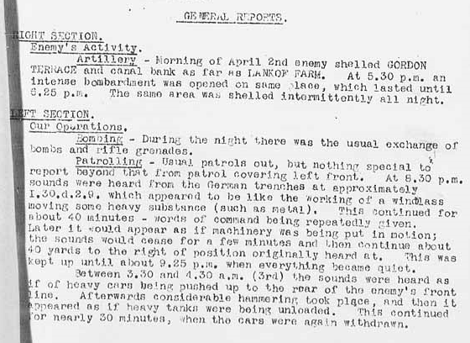

Hill 60, located about three miles south-east of Ypres, was made from the soil removed during the construction of the nearby railway line. Because it was a small area of elevated land in a very flat landscape, it had singular strategic importance in the battles in the salient, and had been coveted and won and lost by both sides over the course of the war. In April, 1916, Hill 60 belonged to the Germans, and the 5th battalion, including Wilfrid, were occupying trenches directly across from it.

Reading the brigade diary shows how unrelenting the war was. If you were in the trenches, you were on perpetual high alert. Quiet days of drilling and inspections were interspersed with days like March 16/16:

Enemy’s artillery very active between 1 and 3 p.m. Throwing 732 5.9” and 8.2” shells around our defences. Germans threw over 1200 shells in our brigade area.

Or April 2/16:

Day quiet on our front but active on our flanks at Hill 60 and the Bluff. Built new cemetery.

Much of the activity is related to German artillery barrages, most of which can be “quieted” by a commensurate response, but German snipers also make pretty regular appearances in the diary entries. In fact, the 5th battalion commander notes that on April 17th, only one day after relieving the 10th, the “enemy’s snipers were busy.” They had picked off seven men in trenches 38-44, six of whom were wounded and one killed. The next day four more were wounded.

As the month wore on, sniper activity diminished as the fifth’s trenches became the target of near daily German artillery barrages. From April 19th onward, bombardments were reported regularly, increasing in accuracy and intensity with each passing day.

Troop Rotation
The Canadian military knew no-one could stay in the front-line trenches for more than a few days without risking full mental collapse. Even when no over-the-top offensive was in their future (and that appears to have been a rare occurrence), the men were in a state of near-constant stress. The risk of death or dismemberment from enemy bombardment and sniper attacks was real and always present. Even on days when no heavy bombardment by the enemy occurred, the battalion diary contains a record of at least 1 – 4 privates losing their lives on a daily basis.

So, a rotation system was introduced to provide frequent and extended breaks from the front, a “tour” of duty that entailed 5-6 days at the front, followed by the same number of days in support trenches, 200 to 400 yards in the rear, then to reserve billets, 800 – 1,000 yards from the front (where troops were typically deloused – very temporarily - and bathed), and finally to billets (typically in barns) in a half-ruined village four or five miles back.

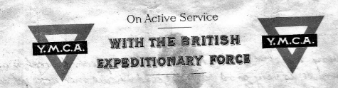
Many of Wilfrid’s letters were written while he was in the near or far rear of the action. While reading the letters, I’d noticed that many of them were written on relatively large pages (about 8.5 x 11 format) with a YMCA logo at the top:

These letters were written when Wilfrid was situated in a reserve billet that included the very popular YMCA hut. These huts were set up to provide some level of comfort, refreshment and companionship to men that might otherwise turn to gambling or other shocking, non-Christian pursuits. These and the Salvation Army huts provided free coffee and tea (and apparently writing paper, too), and they sold candy, favorite food items and tobacco. One trench soldier said, “We would have been utterly lost without it, although we grumbled at the terrifically high prices we had to pay.” (Cook, 393).

Wilfred’s First Experience of Shell Shock

But then on April 24th, what started as just another quiet day in the trenches was transformed into an afternoon of death and living burial for men of the fifth. The Germans launched a non-stop four-hour barrage of heavy artillery on the trenches 38-44, which happened to be situated directly across from Hill 60.

Although his letters are sparse to non-existent from mid-March until later in April, we can piece together a lot from the letter sent by his commanding officer (Lieughtenant M.S. Hunt), Fifth Battalion and 1st Division War diary entries.

The 1st Division diary is the driest of the these documents, reporting that 275 Canadian shells were no match for the 900 German shells that were blasted into Canadian trenches, most of it focused on the mid-section (5th battalion location). The shell metrics for a heavy bombardment are around 400 -450 enemy shells, so this bombardment was “intense” by any measure.

The Fifth battalion diary for April 24th was relatively detailed and described a bombardment unprecedented in intensity that lasted for four hours:

Enemy started a most intense bombardment on our front commencing about 2 p.m. and kept it up till 6 pm. – utterly wiping out our front line. He used all calibre guns and trench mortars. Our own artillery replied most effectively absolutely demolishing his trench system on Hill 60. After the bombardment had finished one of the enemy was noticed waving a white flag from the remnants of the trenches. Whole trenches [Canadian trenches – ed.] were completely blown in and when the bombardment ceased our men were just holding small holes here and there. The morale of the men was excellent throughout it all. The Battalion was relieved by the second battalion, the relief not being complete until 4 a.m.

The war diary of the Second Battalion stated: In evening relieved the 5th Battalion in trenches 38-44 inclusive. 5th had been badly shelled and trenches were in very bad condition.

The First Division Artillery Report gives a more detailed account of the 24th:
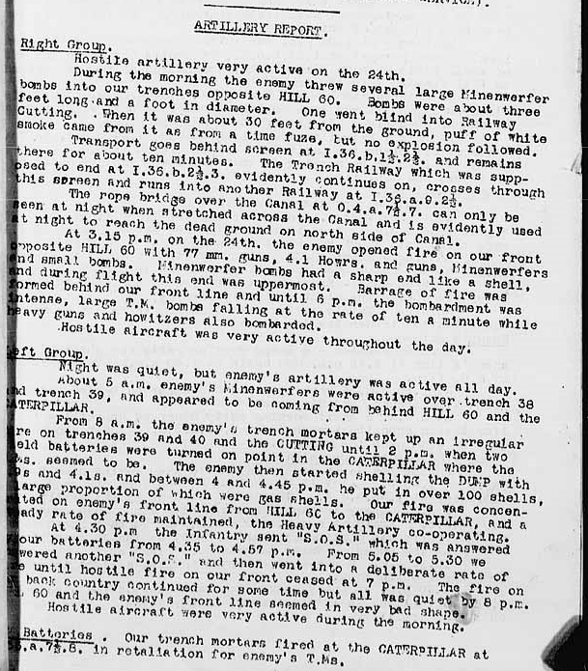

Alexander Dunlop received a letter from Wilfrid’s commanding officer, M.S. Hunt, written in the early hours of April 25th, likely immediately after the 5th had been relieved by the 2nd Battalion. Hunt first assures the family that “he will be O.K.” He explained that Wilfrid “stood bravely to his task under the most awful concentrated enemy artillery bombardment since the beginning of the war, and he with many more of us was buried more than once by the effects of high explosive shells.” And he “came out without wounds excepts from strain and shock,,,and will be OK After a bit of rest in the hospital.”

“Our trenches were only from 30 to 80 yards from each other. The Bosh opened on us with all kinds of dope and kept it up for five hours. Then thinking we were completely demoralized shut off their artillery and came up to their own front lines to for up for a charge our our trenches, but they finding the 5th ready and anxious to have them come over hesitated. One fellow, who could speak English very well called out to us, asking us if we were “all dead” or “ready to give up.” A hundred Canadian voices answered thuswise, “Come on over you S. of B-s!” but they did not come and then our own artillery gave them H--. Worse than they gave us and after it was over we could plainly hear the groans and cried of the wounded Bosh. We were relieved at 2 a.m. and this if the first rest I have had for 48 hours. Thus ends another chapter in the history of Hill 60.”

Hunt was from Neepawa himself, and it’s clear that the Neepawa men looked after each other and took it upon themselves to keep Neepawa families informed. Only a Neepawa-born-and bred commanding officer would have taken the time to write a detailed letter of comfort to a family within an hour of the wounded man’s removal to a field hospital --especially having gone without sleep for 48 hours.

George Fairbairn Writes to Nellie Dunlop from the Trench Dressing Station

Another Neepawa boy (George Fairbairn) in the 5th battalion wrote a very kind letter to Nellie dated May 4th. He had been put in charge of the Trench Dressing station, so could give her a first-hand account of her son’s condition, and was obliging Wilfrid who had asked him to write.

As it happened, by May 4th, Wilfrid’s condition was very poor indeed. He had gone back to the trenches far too soon. Hunt had suggested that Wilfred would be spending several weeks in the hospital, but Wilfrid refused to stay any longer than six days (from April 24-30). As George reported, six days was not enough for “severe shell shock” but Wilfrid was “in a big hurry to get back” even though George thought “he wasn’t looking any too well” and had a high temperature to boot. His medical records indicate he was suffering from “gastro-enteritis” but in George’s opinion “he needs a good rest after such a shock.”
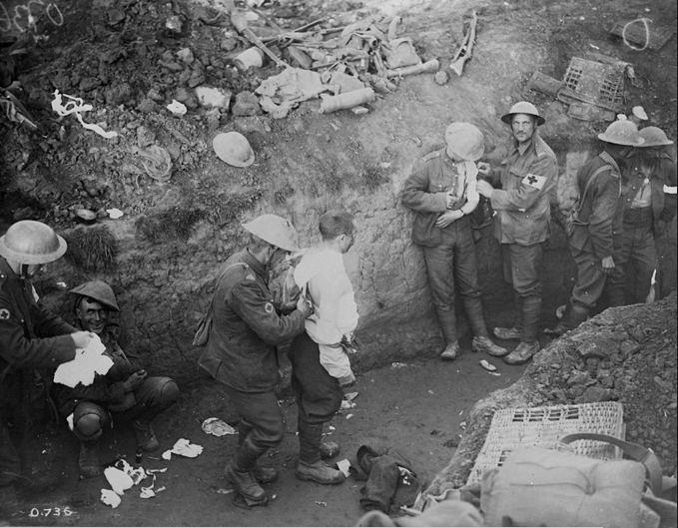
Field Dressing Station at the Battle of Courcelette

An interesting side note about George Fairbairn: He signed up in the summer of 1915 and sailed over in The Corsican in September of that year, just like Wilfrid. His occupation was listed as “druggist” and he became a Sargeant in charge of the 5th battalion field dressing station, which was the first place a wounded soldier arrived at – if he was lucky enough to get there. The field dressing stations were rough places, really not much more than trenches with wound dressing materials, in which the soldiers were triaged according to the severity of their wounds.

George was a lively and dutiful writer of letters to the Neepawa families of the Neepawa wounded. He wrote two in total to Nellie Dunlop, this first one when Wilfrid suffered from terrible shell shock, and then later when he was wounded at Courcelette.

I checked on George’s fate, and found he survived the war, returning to Canada in September of 1919, but he was wounded three times: a minor wound in November of 1917, and then in 1918 he was gassed twice, suffering first with burns to his face and then burns to his eyes – but, despite that, he never left the battlefield from his arrival in Belgium in early 1916 to the end of the war. He was promoted to Lance Corporal, then to Sargeant, and finally, he received the Meritorious Service Medal in recognition of valuable services rendered in France and Belgium in 1919. After being gassed for the third time – and recovering – he was awarded the most-wanted award that all Canadian soldiers desired the most – 14 days paid leave to Paris in early 1918.

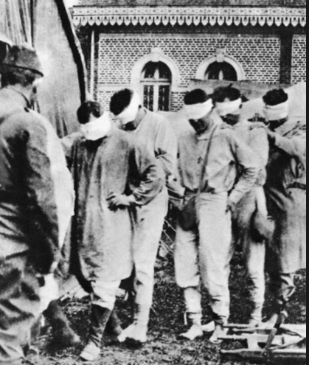
Like Wilfrid, George died as a civilian at a relatively young age. His army records were “updated” at one point with a carelessly scrawled note in red pencil that states: Deceased 20-7-46. Born in 1882, that puts his end of life at age 54. Wilfrid died in ‘41 at the age of 48, so they both shared a lifespan that was cut off in middle age. One suspects their war experiences had more than a little to do with their early deaths, but we can never be sure.

Wilfrid’s Description of the Bombardment
It was more than just a major bombardment; it was a nightmare scenario of six days without sleep in muddy, wet, filthy, ill-equipped trenches:

This bunch of trenches we were occupying had no sleeping accommodations at all and were very wet so most of the boys had bearly (sic) any sleep for over six days and were in no condition to face such a bombardment. Believe me when one of those nice big shells lands quiet (sic) close to you the explosion sure jars ones nerves. The ground fairly rocking like an earthquake...and old Fritz was throwing them at us by the hundreds.

Evidently, the 5th occupied these same trenches opposite Hill 60 (which must’ve been somewhat less than demolished as reported by the 5th commander) right up until the time they left for the Somme in September.

Wilfrid was finally well enough to write to his mother on May 10th. While he was still in hospital from with gastro-enteritis induced by the shock and, no doubt, contaminated food, he was scheduled to return to the trenches immanently. He was anxious to reassure his mother that he “was lucky; mighty lucky.” He goes on to say that the four-hour bombardment was “a regular hell...the air fairly shrieked with shrapnel and high explosive shells. I was badly shaken and was vomiting for nearly two days afterwards.”

Unfortunately, half of the second page of that letter is missing, and the top half was badly damaged, so it scanned poorly. Here is the text of the top half, as best I can decipher it:

However, I am quite well again and only hope that I never get anything worse. All that I owned was buried.

He wrote his sister, May, on that same day (May 10) he wrote to his mother. In that letter (as was often the case) his writing was much more direct and frank about his experience of being “buried up.” It had been over two weeks since the bombardment but had not been able to write until that day: “I have been feeling so rotten lately that I simply could not settle myself down to writing letters...It was the worst experience of my life and I never want to see anything like it again so long as I live.”

The Battle of Mount Sorrel
But there was worse to come. Wilfrid returned to his battalion, and was almost immediately cast into the hell of an exceptionally brutal six-day bombardment.

Wilfrid’s return from the field hospital on May 18th was unfortunately timed. His battalion had only just returned to the same old front-line trenches of the Ypres salient around Hill 60, where they were being subjected to both daily and nightly shelling as the German’s started gearing up for the all-out pounding of the Battle of Mount Sorrel (June 2 – 13). The German’s strategy behind the offensive was twofold: to regain some of strategically important high-ground of the salient that had been previously lost, and to draw troops away from the allied troop build up known to be happening on the Somme – and to keep them pinned down. They planned an all-out assault by the Royal Wurttemberg Corps to attack the peaks of Mount Sorrel, Hill 62 and Hill 61.

Of course, “peak” is a relative term. Like most of Belgium, the area around Ypres is very flat, so occupying any degree of higher ground provides a huge observational and strategic advantage. Mount Sorrel is, in fact, only 30 metres high.

Conditions were cold and wet from unseasonably rainy weather and the trenches were clogged with mud. At 8:30 a.m. on June 2nd, the first day of the Mount Sorrel offensive, what has been described as a “one of the most staggering bombardments of the war”, a “hurricane of enemy fire” concentrated on the Canadian trenches was unleashed. Many of those impossibly muddy trenches and the men who had stood in them, vanished under a sea of freshly churned earth. The Wikipedia entry for the Battle of Mount Sorrel states: “On the morning of 2 June, the German Corps began a massive heavy artillery bombardment against the Canadian positions. Nine-tenths of the Canadian forward battalion became casualties during the bombardment.”
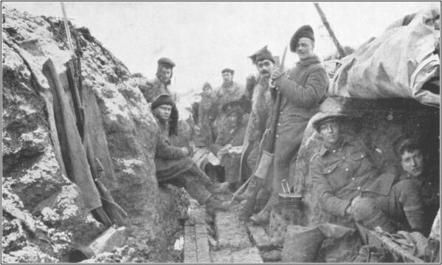
Canadian Trench at the Battle of Mount Sorrel

The horrific level of shelling was sustained until 1 p.m., but there was to be no real respite. Four mines were detonated below the Canadian lines, projecting more mud and human remains into the air as remaining trenches collapsed.

As one officer described it in a letter home, “It seemed as thought the line had been transformed into an active volcano, so continuous were the flashes of bursting shells.” The divisional commander was decapitated, and very few survived, but Wilfrid’s luck held.

The devastating mine explosions were quickly followed by an attack by six Wurttemberg assault battalions. The 5th was stationed on the southern edge of the front line very near Mount Sorrel, so, as you can see from the map below, they were not in direct line of fire from the attacking Wurttemberg corps, and likely escaped the worst of the fighting.

However, the 5th was cited for their valour in defending their shattered trenches, and, although they failed to stop the attack, they made it a costly one for the Germans. Sargeant John Caw of the 5th wrote: “ We had him (the Germans) where we wanted him; halfway up a slope, no cover, and digging himself in, in full view in broad daylight, range about six hundred yards.”
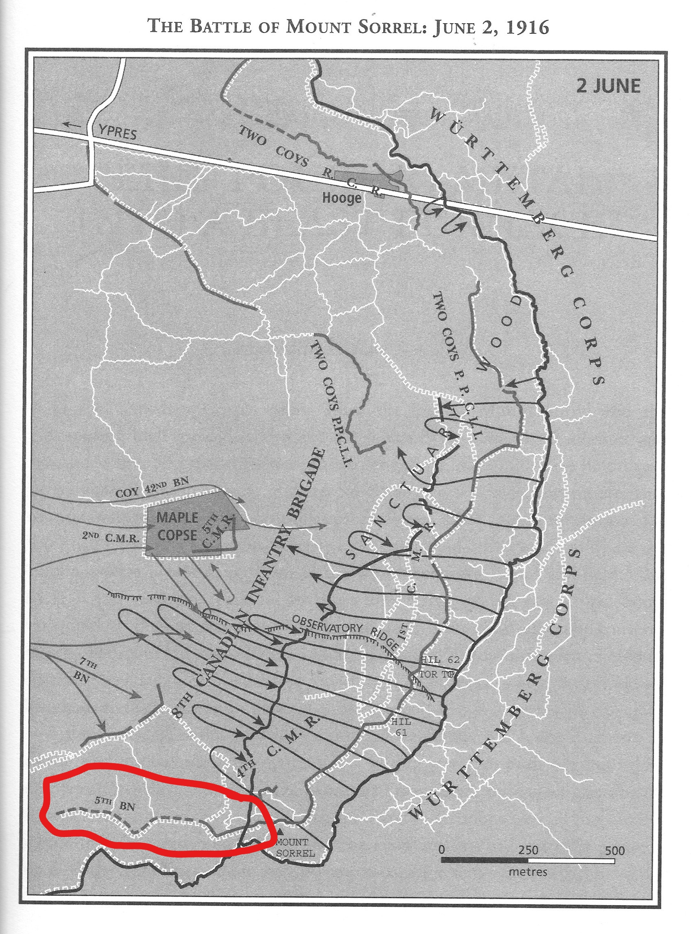

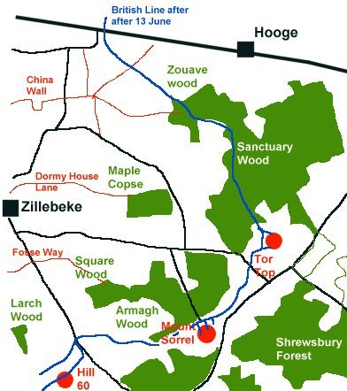
This first day of the Mount Sorrel offensive was a major failure for the Canadians. The Germans successfully overran 1,000 metres of trenches and captured the heights of Mount Sorrel, Hill 61 and Hill 62 as well as the village of Hooge. A counter-attack mounted the next day failed, and three days later, the Germans exploded four more mines directly under the Canadians. The map on the right shows the amount of ground the Germans took from the combined British and Canadian forces at Mt. Sorrel.

However, on June 13th (the fifth had been relieved from front-line duty by this date) the Canadians drove back the Germans and recaptured much of the lost ground.

As a result of the June 13th assault, in which the Canadians (including Richard Buckley’s 3rd division) had gone “over the top” to attack the German positions in Hill 60, 61, 62 and Mount Sorrel, retaking all the high ground that had been lost on June 2. Fierce hand-to-hand and bayonet fighting were the order of the day and the result was pure carnage. To those who fought in this attack, the remainder of the war “was an anti-climax” merely. The total casualties for the two weeks of fighting was 8,700 men. As Tim Cook comments in At the Sharp End, Mount Sorrel raised the curtain on a new level of ferocity and intensity in the war. The German bombardment had been an unprecedented experience for the Canadians, with almost entire battalions shattered by shellfire.”

The 5th battalion war diary for the first days of June record daily heavy and intense bombardments on the Hill 60 trenches that lasted the entire day and into the evening. By the end of the first six days in June, 60 men in Wilfrid’s battalion had lost their lives, while 181 were either wounded or missing. We noted that Lt. M.S. Hunt from Neepawa, who had written the kind if understandably weary letter to Wilfrid’s father immediately after Wilfred had experienced being “buried up” was among the wounded.

June 6^{th was} the last full day for the 5th battalion on the front lines, and it was also one of the worst. Here’s the 5th battalion war diary for that day:

At 9 a.m. the enemy opened up our Front Line with trench mortars and at 12:30 p.m. their artillery opened on our Front Line. The bombardment lasted until 4:30 p.m. by which time the trenches from 40 to 43 were practically destroyed. They opened up another bombardment at 5:35 p.m. Our artillery retaliated on the enemy Front and Support Lines. The Battalion was relieved at about midnight by the 10th Battalion and proceed to Camp D.

On June 7th, the battalion commander summarized the total casualties for the last six days: 60 killed; wounded and missing 181.

On June 11, Wilfrid describes the bombardment to his mother, saying that he “got back to the battalion just in time to go through a bombardment, which was, by far, more fierce and more lengthy than the last..lasting six days. It was worse than “forty Hells” for us. I was knocked about more in the last bombardment than in the first, but I was either in better condition or more accustomed to it, for I came out of it none the worse for my experiences. One big 8 inch shell hit right in front of the cover I was under and the concussion knocked me senseless for nearly an hour. Ye gods! I thought the world had come to an end but within an hour or so I was feeling as good as ever. I never want to be that near to a shell again.”

On the 9th of June, the battalion war diary mentions that battalion will undergo a reorganization: Some men were charged with providing support for the Canadian troops involved in the June Affair (the Mount Sorrel offensive), carrying in wounded that were transported by railway to field hospitals, while others were relegated to carry supplies and others to bury the Canadian dead. Wilfrid’s letters from this period do not mention bombardments at all, although he could not clearly indicate what he was doing. He was grateful to be out of the front-line trenches for any period of time, but his letters from this period are very short and unemotional.

A Note on Wilfrid’s Letters

Wilfrid wrote a lot of letters during his four-year war experience. Some of them are much, much better than others, but he wrote dutifully to both his mother and his oldest sister at least once or twice a week throughout those years. Some of the letters are a little whiney, especially when he’s begging for cash, which he always seems to be doing. But, you can’t really blame him too much. The military gave its solders almost nothing to live on, and he was also doing his darndest to pay off his debts to Mr. Glass via his sister May by assigning half of his pay to her for that purpose. It must’ve been quite a big debt, though. Even by the end of 1916, it had yet to be paid off in full, after 18 months of paying it down.

It’s really amazing to think that the letters he wrote were not just to his mother and sister. The reading audience for the letters now includes his sons (at least, Bill Dunlop, we know read all of them, and kept them safely in storage for his enter life), and now by his granddaughters, his adopted grandson, Billy, and all his great grandchildren, too.

In the majority of his letters to his mother, Wilfrid always ends his letter with an up-beat “Love to all, including Paucha.” Paucha was the family dog, and he was also jocularly referred to as “it”, “the brown fool”, “the hound”, “Tiny”, etc.).

In December, 1917, he tells May that he “received the Xmas card from Tiny which I keep on my desk. Several of the Nursing Sisters have asked who Tiny is. They think it is a girl so I just let them think on. Poor Paucha, little does he know how he is being talked about!”

If there’s a gene that governs a love for animals, Wilfrid must be one familial source. Just as Leona Newton would be as well, with her well known deep and devoted love of dogs, so it’s really no wonder we’re all hopelessly besotted with dogs, cats, birds, turtles, guinea pigs, etc., etc.. And, if there’s a gene that governs a love for creating amusing/teasing nicknames, maybe we can trace the origin of that gene back to Wilfrid as well.

Wilfrid could be charming, sometimes in his letters. However, you can’t help but notice a coarsening – and even a reduction -- of feeling in the letters from May to August. This must be due to his grim day-to-day experiences seeing his friends and fellow soldiers picked off by daily bombardments and snipers’ bullets. Also, the stress of this experience would not have been conducive to writing long, leisurely letters home. His letters do indeed become increasingly formulaic and shorter. As the weeks of trench living in Ypres grind on, his letters become predictable and not very interesting records of packages requested and arrived, expressions of gratitude for their contents, pining for his return to “good old Neepawa” and the casting of aspersions on those individual Neepawa cowards (Freddie Kerr, in particular) who failed in their duty to the empire by refusing to enlist. This may seem at odds with his very passionately held stance opposing conscription, but I think he did firmly believe no-one should be forced to serve, but anyone with an ounce of backbone ought to do voluntarily.

On at least three or four occasions while he is in Belgium and France, he makes contemptuous remarks about men who had not joined the military. For example: “It is amusing to hear about Freddie Kerr. The best thing in the world that could ever happen to him would be to come out here for a few months….Of course, that would be a rather rude awakening for poor Freddie.” (July 10, 1916) Such remarks become increasingly evident in the letters, but he may have been egged on by his mother: “Your remarks about “Percy Kerr” [likely a derogatory name for “poor Freddie”] with his white flannels on were very amusing, but at the same time, someone should have him “pinched” as a deserter.” (August 5, 1916) Even after he was wounded, he kept up his verbal vendetta against young “Percy” (see his letter of October 29, 1916 – in which he says “the war will last another 18 months at least, so Percy Kerr need not worry about whether he will get to France – he will get there and let’s hope it happen quick.”

This sneering contempt for those who stayed at home and even for those in other battalions was apparently becoming endemic among the Canadian ranks – coming to a head in the Mount Sorrel conflict. [At the Sharp End, p.

Maybe it was the prospect of censorship that prevented him from saying much of interest, but many of Wilfrid’s active-service letters become little more than begging for more treats from home.

Here’s a very typical out-take:
“I have not had a parcel from home for some weeks now. I wish the hot weather would let up over there for a few days as I certainly would like some more home-made cake etc. and etc. If you have any homemade jam or preserves that you do not want, don’t forget I have a great appetite?????”

In one letter he’ll tell his mother that his sister Ruby is sending him cigarettes, and won’t they be highly prized when they arrive. In the next letter to his mother, he’ll complain those cigarettes still haven’t come, and continue to complain with each succeeding letter until they arrive.

While he was in active service, Wilfrid begged not for cash but for goodies (including smokes). After he was wounded, the hounding for money starts all over again – sometimes it’s overt, but it’s mostly a kind of disingenuously wheedling for cash. From the hospital, he writes: “I wrote to May the other day and will try and raise a penny stamp to write to Ruby...we have to pay our own postage now you know.”

By way of contrast, it’s interesting to note that Richard Buckley’s letters are full of gratitude just for any letters received. But more on Richard Buckley later.

Also, when describing an incident Wilfrid would tell his mother one thing and his sister quite another – which is not at all surprising. For instance, on October 17, 1916, in the early days of his convalescence, he told his mother, “On Sunday afternoon I was out to tea with some very nice people.” Four days later, he wrote to his sister May about the very same afternoon: “The people around this city are dandy. I was out to tea last Sunday with with seven very nice people to a little party. We had an elegant time. All afternoon we played billiards and then sat down to a square meal. I wont the snooker pool contest so I was entitled the lion’s share of everything at the tea table, and, believe me, I did not leave anything.. Am going out again next Sunday. This is sure a great life. Beats France all to bits.”

Final Days In and Out of the Trenches of Ypres

The battalion returned to the front lines on June 20, where they relieved two battalions in the railway dugouts and zillebeke switch. Here they were involved in work parties and salvage work, as well as carrying out the wounded from the Mount Sorrel slaughter. This work in itself was not risk-free, as on a single day, 21 men were wounded in the course of these work parties.

This period of behind-the-scenes work came to an end on June 30th, when the battalion relieved the 15th battalion and returned to the same front line trenches (39-45), opposite Hill 60. Luckily for them, however, the major assaults of both sides that occurred mid-June were well in the past, but the fighting around Hill 60 didn’t completely end. As Wilfrid pointed out in a letter to his sister in early August (just before his Division was transported to the Somme): “I came through the June mix-ups alright and also the July ones, and am just as good as ever, if not better.”

Wilfrid’s references to the July “mix-up” didn’t tell the whole story, as July was significantly quieter and more peaceful on the front lines than June was. When the 5th returned to Hill 60 front line trenches at the end of June, great offensive shelling on the part of the Canadians, with far fewer casualties and deaths were recorded. A typical diary entry notied very active shelling into the German trenches, with the “enemy batteries retaliating only weakly”. The six-days in the front line came to an end without significant enemy bombardment.

The battalion spent the next two weeks back at the Scottish lines and then in the Corps Reserve Camp, not returning to Hill 60 until July 20th. Desultory back-and-forth shelling followed with minimal casualties and rare deaths. They returned to the Scottish Lines in the rear on the 26th of July for rest, recuperation and squad drills and parades.They got to use the Division Baths and played baseball against other ballations. Significantly, the battalion also participated in practice route marches at this time, in preparation for moving the entire Division 1 to the Somme area. The battalion would only return once more to the front-line trenches in Belgium and the much reduced enemy contingent (most of them had already been sent to the Somme area) made it a very quiet sojourn. Their next task was to make the 126 kilometre journey from Ypres to Albert, France to join the fighting at the Somme, which had been underway since July, with disastrous effect.

Richard Buckley: Surrogate Dunlop Son

Wilfrid’s best friend was Richard Buckley (1893 - ?). An Irish immigrant, Richard joined up at the same time as Wilfrid (August 9, 1915) in Winnipeg, They were at the same training camp and even were lucky enough to share a room in the transport ship that took them to Shorncliffe, England to continue their training. At Mount Sorrel, he was not quite as lucky Wilfrid, whose battalion played more of a supporting role throughout the worst of the Mt. Sorrel battles. Although he survived, his 7th brigade of Canada’s 3rd division, was in the very thick of the action in what was known as “the June show” or the “June affair”.

Richard wrote fairly often to Mrs. Dunlop, who appears to have treated him like a son, writing him frequent letters, sending him parcels and even knitting him socks. His letter of July 4th is especially vivid in his description of the fighting during the Canadians’ Mount Sorrel disaster, a disaster in that it garnered nearly 9,000 casualties in the first two weeks of the month alone – and, like so many Great War battles, trench real estate would be lost and then recovered, and, in the end, the result was almost zero net change to the ground held by either side.

Richard Buckley’s letters were different from Wilfrid’s. While Wilfrid seems reluctant to describe either the daily grind or the horrors of battle (although, with the censor potentially reading every letter, this kind of thing of discouraged), Richard writes with a richness of detail and emotional color that is absent from Wilfrid’s letters. For instance, in a letter dated May 26, 1916, Richard describes where he is as he writes the letter: “I am writing this letter in a little dug-out not very far from Mr Fritz, but I expect to be much closer to the beggar before the week is out. I have been getting along very well since I came up here, and by degrees am getting used to this hide-and-seek trench war. Just now, a few shells are flying overhead, and the big ones go through the air making a noise somewhat similar to a street car, and they sound just as big, and move so slow, too.”

Richard’s letters are very powerful, with a rawness of emotion and sentiment you don’t find in Wilfred’s. When reading them you sense that witnessing the daily deaths and maimings of his fellow soldiers created depths of feeling that were freely mined in his letters to Mrs. Dunlop, to whom he clearly felt very close. In the letter of July 4, 1916, he is especially emotional. Wilfrid never mentions death or the immanence of it. Richard is not afraid to talk about it. He writes about meeting up with other Neepawa boys: “I may say we were all very glad to see each other. I suppose it was because we had seen a little more fighting than usual, and we wondered who had been lucky enough to get through it.”

He writes very frankly about “the June affair” as the Battle of Mount Sorrel was called at the time: I ran across Andy Mitchell. He had just come out of the June affair, and like the rest of us, he felt pleased to be back where we were just then. What we saw during those five days was more than enough to show me at last how very terrible war is, and I surely did see in that time things which at ordinary times we could not bear, but unfortunately they are all too common sights which come as a matter of course.” Richard goes on to describe a particularly affecting death of a young man in his company: “The other day one of our boys was badly hit, and almost his last words were “Well, boys, I’m done. Carry on the good work, and God will give you victory….He died inside two day, though we did our best for him and took him to the station [field hospital or wound-dressing station] in broad daylight. It is hard to see such good fellows go under...”

He opened up to Wilfrid’s mother in a way that Wilfrid himself seemed unable – or unwilling – to do. He was especially affected by the warmth and friendliness of the people of Neepawa, who accepted him so gladly and were “the kindest and most sincere friends that one could ever have...treated by all just as though I have lived my life there, and this I cannot forget. I am sure that at times you must have considered me very odd...which I attribute to an affliction which has often worried me beyond everything, and that is, as you know, a stammer caused by nervousness. Indeed, I felt very thankful to you all who made things so much like home to me that made lose this nervous feeling all the time I was there..To your family I owe more than I can repay, and certainly you have treated me not as a friend only, but almost as though I was one of your own.” The sombre fluency of these letters is stunning. You sense that Richard clearly understood how strongly blind luck was involved in surviving the awful mechanized terror of the war, and how much he needed to communicate his gratitude and love to the world he might be very soon leaving behind.

Richard was born in on the 12th of September, 1893 in Eniskerry, County Wicklow, Ireland, leaving on his own to settle in Neepawa at the age of 20. His family remained behind in Ireland, and his father, Francis Buckley, a farmer and hotel proprietor still living in Eniskerry, was listed as his next of kin in his military will. Like Wilfrid, Richard was a bank clerk, just like Wilfrid, working at the Neepawa Imperial Bank of Commerce. He was about five years older than Wilfrid and comes across as much more mature and thoughtful in his letters. He also has the Irish gift of the gab, and writes in a loquacious and colorful way about his day-to-day life when he’d been relieved from the front-line trenches. Writing about the details of trench warfare was a definite no-no that would never be approved by the censors who read every letter.

Richard was among those very lucky individuals who served for the entire duration of the war without being either seriously injured or killed. He served in Belgium and France with the 7th Brigade (3rd Division) –the famous “fighting seventh” as they were called -- from April 1, 1916 until the very end of the war without once receiving an injury. I suspect his ability to survive the war had more than a little to do with the fact that he chose to become a machine gunner. Machine gunners always had one of the most fearsome weapons of the war between themselves and their enemies, unlike the poor infantryman with only a helmet and a single-action rifle to protect themselves.

The Seventh Brigade included Princess Patricia's Canadian Light Infantry (PPCLI), a well-known and highly seasoned group of elite war vets who had fought with the British in the Boer War, the Royal Canadian Regiment, the 42nd Battalion from Montreal and the 49th Battalion from Edmonton. Richard was a member of the 7th Brigade Machine Gun Company, which could be attached to any of the four battalions and regiments that made up the 7th Brigade.

The 3rd Division occupied a large portion of the Ypres salient (from the village of Hooge to Santuary Wood and down through Hill 62, 61, Mount Sorrel)during the Battle of Mount Sorrel, and Wilfred’s 5th Battalion occupied neighboring trenches just below Mount Sorrel, directly across from Hill 60. Richard’s third division was on the receiving end of the very worst of the German offensive during the Battle of Mount Sorrel. During an especially horrific assault that obliterated trenches and nearly wiped out the entire light infantry group – more than 400 men of the PPCLI were killed on one day during the height of the assaults in early June, 1916.

Another WW1 Horror: Trench Fever

While Richard managed to escape shrapnel and bullets, he contracted a case of trench fever that was serious enough to require hospitalization had to be sent to England twice to recover. The first hospitalization occur in October of 1916 just after the Courcelette offensive, and his medical records show this was the first of several hospitalizations for the condition.

Trench fever is fairly serious disease caused by a bacteria called Bartonella Quintana, which is found in the stomach walls of body lice. It’s interesting to note that the human body louse doesn’t actually live on the body, rather it takes up its insidious residence in a person’s clothing – and, for some odd reason, in the seams of clothing. While it doesn’t live on the skin, it does feed on human blood, and causes severe itching as a result. Scratching the itch can cause the feces of the louse, which contain the nasty bacteria named above, to be released into the bloodstream and so spread the infection.

It causes high fever, severe headache, pain on moving the eyes, skin rash, dizziness, constant severe pain in the shins, and sore muscles, particularly affecting the shins. This all sounds bad enough, but what makes it even worse is the recurrence of the fever (along with the other symptoms) which could rise and then break after a week, cycling through as frequently as eight times before disappearing. Recovery was slow, often requiring several months rest. This is why Richard experienced so many and such prolonged periods of hospitalization. And it often didn’t stop there. It could be experienced in relapse as many as ten years after the initial infection, and cause heart problems.

It was pretty much endemic, given the prevalence of lice embedded in almost every combatant’s clothing and the squalor, filth and cramped conditions of trench life. It’s possible that as many as 30% of WW1 soldiers suffered from this condition in some degree. His final medical record in 1919 states that Richard continued to feel severe pain in his legs even at the time of his discharge.

Although you might think no-one could envy an individual struck down by a chronic disease, it did allow him to escape the carnage of Vimy Ridge, Passchendale, and Hill 70, which decimated his 3rd Division in 1917 and ‘18. No doubt his continuing bouts of Trench Fever were responsible for him being invalided to England in November of 1916, where he remained, safely sidelined for the remainder of the war. He was assigned to the Canadian Machine Gun Depot, at training school for the Machine Gun companies, first at the Crowborough barracks and then at Riseborough, where he was most likely involved in teaching new troops machine-gun use in these pleasant seaside towns.
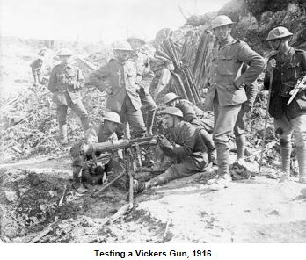
Richard was honorably discharged on June 24th, 1919, returning to his bank clerk position at C
IBC in neepawa on July 4th of that year. During the war, his leadership qualities were recognized, as he was promoted first to Corporal and then to the rank of Sargaent.

Wilfrid was also promoted to Sargaent (Richard B.’s letter of Sept. 20: “I noticed he had a stripe up and had to congratulate him upon his promotion. You see, he will now be a leader of men.” But, for reasons that will become clear as this narrative progresses, he lost his commission while he was serving as a military clerk in England.

The Somme

Wilfrid and Richard arrived at the Somme battlefield (Albert, France) to a front-line experience of much greater intensity and ferocity than Ypres. As it happened, the more relaxed nature of the front-line experience at Ypres post-Mt. Sorrel action was almost wholly a result of the Germans having deployed most of their experienced, and feirce, troops to the Somme.

The preceding two years had been marked by defeat for the entente troops, and an especially egregious waste of French, British, Canadian and Australian lives. As Tim Cook crisply remarked, “the entente needed a victory.” (Cook, 405) With a promise of concerted, coordinated offensive efforts by all parties of the entente to break through the stalemated trench situation, the Somme was to be the largest British offensive to that point in history. (Cook, 406).

Of course, nobody thinks of victory when the Somme battles are mentioned. Much has been written about the first day of the battle of the Somme on July 1, 2016. By the end of that day, of 120,000 British soldiers involved in the day-long attack, more than 19,000 died and 38,000 were wounded. That first day came to represent the futility and waste of the war, and the grotesque incompetence of the generals who were its strategists.

But what happened next? Somme area activity appears to have devolved into the identical trench-based stalemate of mutual bombardment, punctuated by occasional skirmishes into the hell of no-mans’-land we’ve seen with the Canadian experience in Ypres – except with much greater artillery power. The intent from July 1 to September 14th was the same as the intent at Ypres: to simply wear down the enemy and straighten out trench lines by gaining a few feet here and there. That hardly constitutes a strategy, but it served as the template for the actions that pervade this most wearying of wars. As Tim Cook states: “The battles of Poziers, Longueval, Delville Wood and Guillement” – all fought during these two months – “left thousands of dead, and for little gain.”

By the time the Canadians arrived at the Somme in early September, two months of fighting by the British and French had resulted in the gain of only 8 kilometres from the enemy, at the cost of another 100,000 casualties -- and more troops were desperately needed.

The Somme had become synonymous with death and maining on an industrial-scale, and you can bet the Dominion soldiers had a pretty fair idea of what kind of slaughterhouse they were marching into. The Canadian Corps had suffered 9,000 casualties at Mount Sorrel, but this number was about to become negligable.

The Somme battlefield was a nightmare landscape. As Tim Cook describes it, “It ws a wasteland of ruined farmers’ fields; scummy, water-filled shell holes; and acres of unburied corpses...a mixture of blackened flesh and broken bounds with thousands of tonnes of metal and shattered structures.”

Canadian 2nd Brigade Arrival in Albert

The BEF commander, Field Marshal Haig wanted the newly arrived Canadians to have a two-week opportunity to become acclimatized with the area prior to the first major Canadian offensive, scheduled for September 15th. It was a tall order to move the entire Canadian Corps from Ypres to the Somme, but it was apparently done like clockwork. The Division 1/Second Brigade diaries record a meticulously well-worked out plan that got all battalions, brigades and companies across the 140 mile with minimal problems and minimal stress to the troops.

Wilfrid’s journey to the Somme started in late August. On August 22, the battalion war diary states that the men “paraded at 2:45 a.m. and marched 32 miles to Arques, France, where the men entrained and proceeded by rail to Candas, France. From there, the battalion marched 3 miles to billets at Fieffes, and then on to the Brickfields area near Albert.”

The entire 1st Division left Ypres at this time, leaving the 3rd Division, including Richard Buckley, behind to maintain the front line for another week. He was to follow fairly soon after as his division made the same journey to the Somme area (Albert, France). As Richard said in his letter of September 20, “We were glad to meet again, and have been together for an hour or two.” Wilfrid had already been through some major fighting at this point.

On arrival at their destination in France, the thousands of entente troops were stationed in an area called the Brickfields, just outside of Albert. The Brickfields was a sea of tents, but apparently there were insufficient tents for the Canadians.

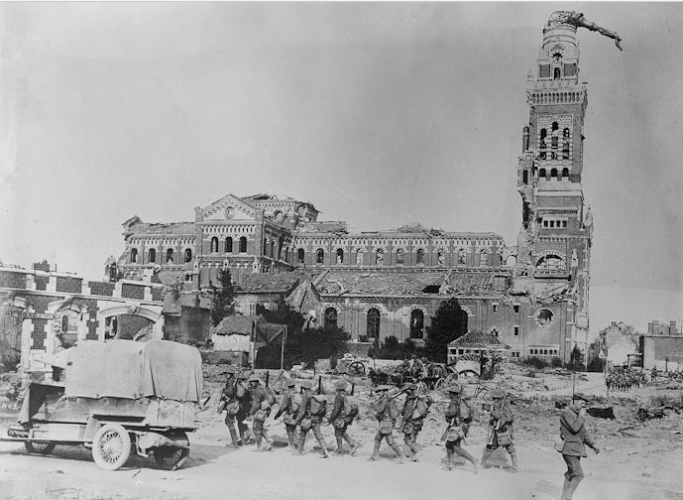
The Toppled Statue of Mary Above the Troops in Albert

The Town of Albert itself stood out because it had been pretty much bombed into oblivion. The statue of the Virgin Mary perched atop the town’s cathedral had been shaken from its moorings and was now nearly horizontal. Engineers had bolted her down so she wouldn’t fall and hurt the troops, but the famous superstition among the Canadians was that a divine hand prevented her falling, and when she finally did fall, the war would be over.

The First Division Moves into the Somme Trenches (September 7th to September 26th)

Having been acclimatized to the area, Division 1 of the Corps officially relieved the 4th Australian Divison in the trench system near Albert.Wilfrid’s Second Brigade moved into the Left Section of the system on September 7th. The Australians had just been shot to bits in a failed assault intended to capture a fortified, abandoned farm that would have been an effective strategic point for advances on the longstanding German stronghold at Thiepval.

The 5th Battalion was sent to the trenches situated in the Chalk Pits. These chalk pits were described by other soldiers (from the 102nd battalion) who had previously occupied the area as “a muddy depression honeycombed with inadequate shelters, lying between Baily Woods and Pozieres. When wet, the chalky soil was quickly reduced to a deep stickiness which made every movement a labour.” To make matters worse, “the chalk in the ground showed as white streaks against the mud, making the trenches highly visible to the enemy. (Cook, 425). And the German snipers knew every inch of the area intimately, having studied the entente trench system for months now, and knowing its weakest points, causing a continuous trickle of daily deaths and injuries, and eroding the already shakey morale of the brigade. And why was morale already affected? Apart from hearing about the horrors of the Somme for two months, the men were experiencing a level of bombardment on a daily basis that had been but weakly foreshadowed at Ypres.

As General Arthur Currie noted in his war diary: “absolutely continuous shelling night and day. Our casualties very severe and trenches very bad.” In the first sever months of September, the Canadians lost 769 men during a time when none of the Canadians ever left their trenches.

Here’s a photo taken of the Chalk Pits by the Australians, just weeks before Wilfrid and his 5th Battalion relieved them:

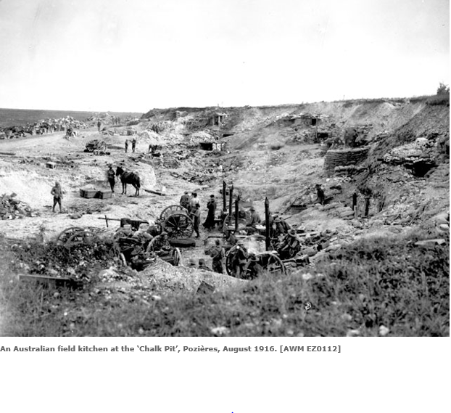
And here’s the same Chalk Pit today:
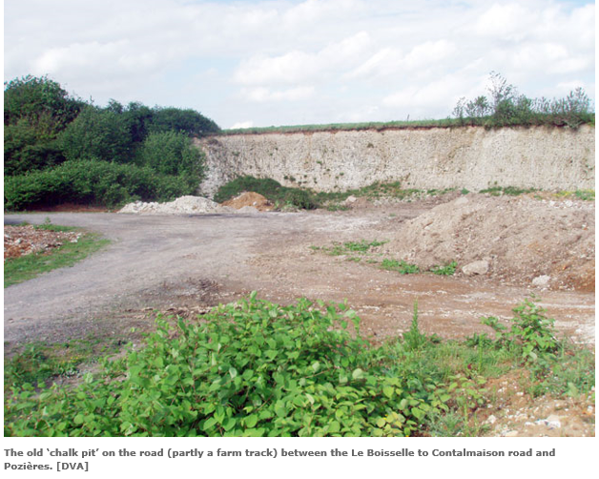
Wilfred and Richard wrote few letters during this time. Wilfrid’s letter from early September to the day before his wounding (September 26) hint that he’s involved in something intense and momentous but beyond that, he says very little. Of course, he can’t writing freely because of the military censorship of any but the most vague descriptions of action in soldiers’ letters home.

On September 6th, just before the first Somme offensive, he says, “I will have a lot to tell you some day about where I am at the present time. Sorry it can’t be told now but you know the censor would strongly object….don’t worry about me. I came all through Ypres without any harm and I feel quite confident that I will come through this.”

The Boys of Neepawa Start to Fall

On the 17th of September, he alludes to the fact that he’s writing “amid considerable excitement.” He does more than hint, though, that he’s had his first over-the-top offensive experience: “Am sorry to say that Garfield Mitchell was killed about a week ago. He went over in the charge but was killed by a shell shortly after. It is pretty tough but still we all have to take our chances. Andrew Mitchell was wounded in the charge but should recover.”

Garfield Mitchell died at the age of 24. He had gray eyes, brown hair and a fair complexion. Like Wilfrid and Richard, he was a bank clerk-- a popular calling in those days, apparently. Wilfrid’s lack of emotion when informing his mother of Garfield’s sudden end may seem odd given that he likely went to school with this boy (they were both born in 1893), and just as likely, given that Neepawa was a small town, may have worked alongside Garfield every day. But we’ve noted the coarsening of Wilfrid’s feelings and higher nature during the war years. When you know each day could well be your last, you’re less likely to mourn the loss of your peers, particularly if their death may have meant in some superstitious way that you were therby spared – after all, on the 9th of September Wilfrid was occupying a front-line trench, and if that shell had fallen differently, it could’ve as easily taken Wilfrid’s life. At least, one can see how this kind of logic may have influenced thoughts and feelings at thr time.

But what exactly was going on at this time? Where and when did the “charge” take place that took the life of Garfield Mitchell, sparing his older brother Andrew only to be severely wounded?

We know that, from the moment they were transferred to the Chalk Pit, the Canadians were subject to unusually intense enemy bombardment and frequent offensive charges into their trenches.

As the battalion war diary for this period indicates, the men were terrorized by heavy and prolonged daily and nightly shelling interspersed with sudden early-morning murderous assaults. Wilfrid’s experiences at Ypres had transformed him into a battle-hardened veteran who could more easily withstand the shock of the shelling. Living through the shelling of Ypres – and especially the heavy bombardments that buried him alive twice – prepared him mentally and physically for the ordeal of the Somme, and it likely enhanced his capacity to survive the experience.

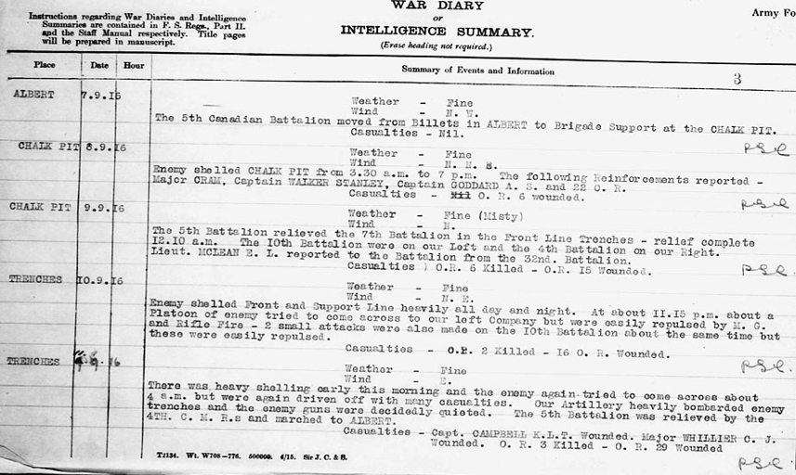
Unlike Wilfrid and Richard, Garfield Mitchell only entered into active service on the 25^{h} of June, 1916 at Ypres, after the worst of the Mount Sorrel fighting had past. He was a rookie and his slight experience at the tail-end of the Ypres engagement wouldn’t have begun to prepare him for the savagery of the Somme. There’s little doubt that his inexperience had at least some bearing on his early death. Garfield was killed in action only two and a half months after the start of his active service in Europe.

Practicing for the Courcelette Offensive

The trench bombardments and raids of the Chalk Pit were rough, but nothing compared to terror of going “over the parapet” and advancing on enemy lines. To prepare for the major offensive of the Battle of Courcelette, which would begin on the 15th, it was decided to “launch a series of minor operations to push out the Canadian lines and gain more favourable starting positions.”(Cook, 426)

Sadly for Garfield Mitchell, who was a member of the Second Battalion, and luckily for Wilfred, who was in the 5th, the Second Battalion rather than the 5^{th,} was chosen to attack the German lines in the early hours of September 9th.

Descriptions of that day differ, but if we take the Second Battalion War Diary as definitive, it went something like this:

Companies moved into position prepatory to attack, 3 p.m., companies entered “JUMPING OFF TRENCH”, dug toe holes, and fixed bayonets. 4:25 p.m. everything in readiness. 4:45 p.m barrage opened, men leaped over parapet, and advanced as close as possible to german front line. 4:48 p.m. barrage lifted, and our right companies gained objective. On left, our men were held up by heavy machine gun fire. At this time one of our officers, Leightenant J. Pringle, alone, charged the machine gun which was holding up his men, and silenced the gunners, himself being riddled with bullets. 5:24 p.m message displaced by attaching party to Bn H.Q., stating that objective had been gained of 550 yards...Our casualties were – 2 officers killed, 8 officers wounded (3 of those died), Other ranks 43 killed, 142 wounded.

In this fairly minor offensive, not important enough to be included in any but the most comprehensive book on the Canada’s role in the war, almost 1% percent of all the 6,000 Canadians who lost their lives on the Somme were killed – including, of course, young Garfield Mitchell from Neepawa.

Canadian Mounted Rifles: Losing Their Mounts

And what about Andrew Mitchell? Andrew signed up soon after the outbreak of the war (in December, 1914) –earlier than Wilfred and Richard, who signed up in August of 1915) and had been in combat much longer than his brother, whose inexperience was likely a significant factor in his death.

Andrew was assigned to the 1st Battalion, Canadian Mounted Rifles (C.M.R.), which had originally been a mounted infantry unit. When the battalion arrived in France in September of 1915, it became clear very quickly that mounted infantry would be of little use in trench-based warfare, and the battalion converted to common boots-on-ground infantry.

By the time he got to the Somme where he would be grievously wounded, Andrew had been through a lot. 80% of his battalion was famously and thoroughly decimated the day the Germans launched their first assault in the Battle of Mount Sorrel on June 2. A total of 557 of its 692 members were killed, wounded or captured that day. Please see the 1st CMR Battalion War Diary entry for this day in the appendix. Luck was clearly with Andrew that day inYpres, but it ran out at the Somme, as it did for so many others.

Battle for Mouquet Farm
Luck was certainly working in Wilfrid’s favor. As the battalion diary shows (bottom of the page), the 5th retired to billets in Albert for rest just before the first significant offensive of September 15th, which included the Battle of Mouquet Farm (during which Andrew Mitchell was wounded, as described below) and the main Battle of Courcelette itself.

The strategically significant and fortified village called Mouquet Farm had been held by the Germans, who repelled attacks by both English and Australian troops (who called it “mucky farm,” since July 23. The attack was not successful, but it did achieve the goal of diverting German attention from the buildup of troops in nearby Courcelette.

Wilfrid may have been misinformed when he stated in his letter of September 17th that Andrew had been wounded in the same September 9th offensive that had taken the life of his brother, Garfield. Andrew received a serious Gun Shot Wound (G.S.W.) to his left hip and a shrapnel wound of his left knee “while in a trench” during the September 15 offensive, a little less than a week after his younger brother was killed.

The Mouquet Farm offensive seems unusually poorly planned, even by WW1 standards, with the Canadian troops being bombarded at one point in the battle by their own artillery. As Tim Cook tells it, “the 1st CMRs pushed into the enemy lines as part of the first wave, but suffered heavy casualties from friendly artillery fire and especially from defenders in German trenches, who poured machine-gun fire into the Canadian ranks.” This overview of the action – written one hundred years after the fact – doesn’t do adequate justice to the suffering inflicted that day.

What follows is a very lengthy extract from 1st CMR war diary from September 15 that more vividly captures the chaos, horror and incompetence of warfare on the Somme:

Objective: to raid Mouquet Farm and dugouts in the vicinity. Their objectives was the enemy trenches which they were to bomb, and clean cut, doing as much damage, and to cause as great loss to the enemy as possible. On reaching their objective, they were to remain in the trench for a period of ten minutes, after stated time to return to their own trenches. At zero time 6:20 a.m the party were in shell holes out in front of their trenches, and in rear of where our Barrage should have been. However, at 6:25 it was found that our Artillery, instead of playing on the Enemy’s line, many of the shells fell amongst our own party, inflicting many casualties, including the officers leading the party. After the barrage lifted it was found that the enemy’s line was intact and very strongly manned, and when our men advanced they were met with a shower of cylindrical sticks as well as heavy rifle and Machine Gun fire. In reply our men answered with bombs and rifle fire. This party occupied a line of shell holes in front of the Enemy Position from which a heavy fire was kept up by the enemy until our men had suffered many casualties.

At 6:40 the enemy began shelling our front line vigorously. The hits were infrequent until about 10:30 a.m. when the range was perfect, with the result that many casualties were inflicted. This shelling was kept up without intermission until 7 p.m.. After this it was shifted back and barrage established between front line and support which was kept up until midnight. The machine gun and rifle fire, especially sniping, was incessant throughout the day.

The Companies suffered heavily, especially the right company, in which out of 5 officers, three were killed and two wounded. The total casualties during the tour were as follows: 6 officers killed, six wounded. 64 Other Ranks killed, 173 wounded and 9 missing.

The Wounds of Andrew Mitchell

When he was sent to England, “the wound was very septic. Pieces of bone were removed on three different occasions. The left knee joint became infected, was opened and pus drained.” The doctor who initially treated Andrew in the field, noted that “the wound was very deep and very unhealthy looking and required drainage to be inserted for two days, and afterwards the wound to be packed with sulphur. I removed some loose fragments of bone at operation but many still remain attached to rotator tendons.”

He was sent to a Canadian military hospital in Bramshott, England to recover, but Andrew did not recover well; Andrew’s hip, thigh and knee remained infected until October, 2017 – over a full year – and the result was “almost complete anklyosis of left knee joint, with only slight movement of hip joint.” In other words, he could bend neither his knee nor his hip ever again, and he was thereafter seriously handicapped. He would never be able to walk without extreme difficulty again. Coincidentally, a full year after Theipval Ridge battle, and after recovering from his relatively minor leg wound sustained there, Wilfrid was assigned to clerical duties in the No. 12 Hospital at Bramshott, where he met up with Andrew Mitchell who was still bedridden with his wounds. Wilfred said, “Andrew Mitchell is in this hospital. I was talking to him the other night He is looking very well but left leg is crippled. He is goinjg back to Canada on the next boat.”

WW1 gunshot wounds, one of which would “invalidate” Wilfrid as well within a week of Andrew’s wounding, were almost always problematic. Infection was a serious and frequent complication (Wilfrid’s wound also became seriously infected):

Infection was a serious complication for the wounded. Doctors used all the chemical weaponry in their arsenal to prevent infection. As there were no antibiotics or sulphonamides, a number of alternative methods were employed. The practice of ‘debridement’ – whereby the tissue around the wound was cut away and the wound sealed – was a common way to prevent infection. Carbolic lotion was used to wash wounds, which were then wrapped in gauze soaked in the same solution. Other wounds were ‘bipped’. ‘Bipp’ (bismuth iodoform paraffin paste) was smeared over severe wounds to prevent infection.

Andrew was in and out of British hospitals until November, 1917, when he was finally “invalidated” as medically unfit and sent back to Canada with a medical discharge. He was under-weight by 30 pounds. His height at discharge was 5’11”, weighing only 130 pounds he was a poor specimen. He’d been in English hospitals for 14 months and would be forced to remain in Canadian hospitals for the next nine months.

On returning to Canada, Andrew was admitted to the Manitoba Military Hospital in Winnipeg, where his condition was more fully assessed: “There is permanent anklyosis of both hip and knee, left side. Hip considerably adducted [twisted inwards]. Recommend excision of hip joint so as to restore movement.”

He was admitted to the Winnipeg General Hospital on March 26, 2018, where he had his hip excised – cutting away the flesh to halt current and prevent future infection. The result was “considerable suppuration and swelling after operation [i.e., loads of infection again]. However, his doctor declared that by May, the “wound is healed”, despite the fact that the “patient complains of difficulty in moving his limb.” A week later, the “wound had broken down again.” In June, “particles of bone were being discharged from the wound site, and the patient “is advised to use a walking stick.” And basically sent home and told to dress the “fresh daily discharge” ever day.

After having part of his hip removed, he performed clerking duties at a Military Record Depot. Bone loss in his hip and femur meant that his left leg was two inches shorter than the right, and he was permanently crippled-- but he had been promoted to the rank of Corporal and decorated with a gold bar.
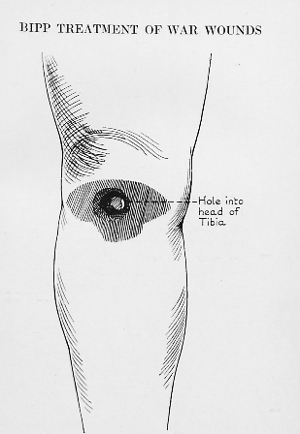

The Battle for Courcelette
And, finally, we come to Battle of Courcelette, in which so many Canadians were wounded and killed. But Wilfrid was not among either of those, as the entire 1st Division was resting up for the Thiepval Ridge offensive coming up on the 26th. The star division of the Battle of Courcelette was Richard Buckley’s third division.

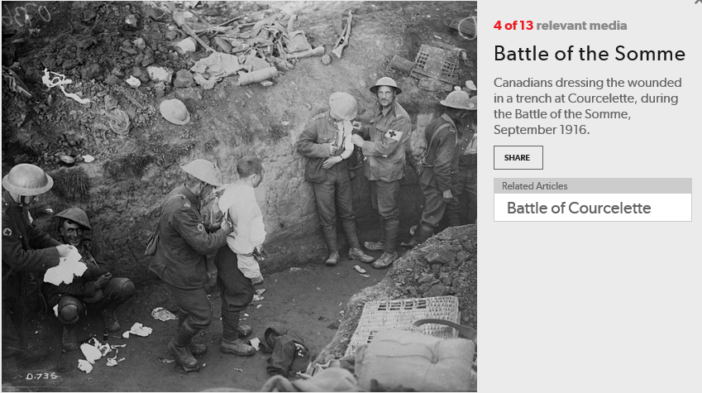
September 15th was the day of the main assault on the village of Courcelette, and it was a day of bloody victory for the Canadians. The 2nd Division, with the 3rd Division (Richard Buckley’s Division) protecting the left flank, managed to take the village from the Germans.

The 1st Division, of which Wilfrid’s 5th Battalion was a part, were not involved in this very famous Canadian assault. That day, Wilfrid’s battalion was well behind the lines at the Brickfields of Albert, participating in training exercises. The entire 1st Division was resting up for their next scheduled assault on September 26, the Battle of Thiepval Ridge.

So, the Dunlop family has been confused for many years. Robert and William Dunlop both thought that their father was wounded at the Battle for Courcelette – the first battle in which the lumbering British prototype of the tank was launched, with very limited success. Wilfrid’s final day of soldiering in France occurred during the Battle of Thiepval Ridge, some 11 days later.

This battle was also the first one in which the British-invented tank made its debut. It’s interesting to note that it was developed primarily as a means to crush the barbed wire that impeded the troops from attacking enemy trenches. However, they were far too slow, mechanically unreliable and easily knocked out by artillery fire to be regarded as menacing.

Six of the new tanks were supplied to the 2nd Division, who were the main assault troops for the battle, charging straight into the town of Courcelette – and being mowed down by the defending Germans’ machine gun fire and artillery. Despite terrible odds, the Canadians prevailed and the battle was deemed a “stunning success”. The Canadians fought long and hard and by the end of the battle, the town of Courcelette had been captured from the Germans, but, like most WW1 victories, it was a very costly one. More than 1,000 Germans were captured, and the same number killed, while the Canadians racked up a horrific total of 7,230 casualties.

Richard Buckley wrote to Nellie in mid-November from a Convalescent Hospital in Kent. As usual, Richard’s letter contains a rich amount of detail and emotion as he describes the battle:

I was not in the same engagement as Wilfrid in September [Theipval Ridge on September 26th] as we were out for a rest just then, after our very brilliant performance on September 15th and 16th as our brigade had a big hand in the advance made on those days, and the 15th of Sept. will not be forgotten when Canada’s work in this war is written. Charles Thompson was slightly wounded in our last visit to the Somme. His battalion had a rough time and Charlie said he had extraordinary luck to come out as he did. Out of a crew of eight on his gun, he alone got through, and though slightly wounded, he remained with his gun till his unit was relieved next day. Poor Reid Howden went under in the same attack. I understand he was just hurling a bomb from the trench when he was hit bad enough not to let him recover. Harry Woolsey felt Reid’s death very much, having been with him so long. I am sorry to say our own company lost a few of our oldest and best men, including an officer who, to me at least, was the finest officer I have even seen in France.

This “break in” by Canadian troops that managed to dislodge the Germans from the town of Courcelette was the first action at the Somme that could be declared a victory. “The larger British offensive,” declared Tim Cook, “had achieved minor results at best.”(p. 468)

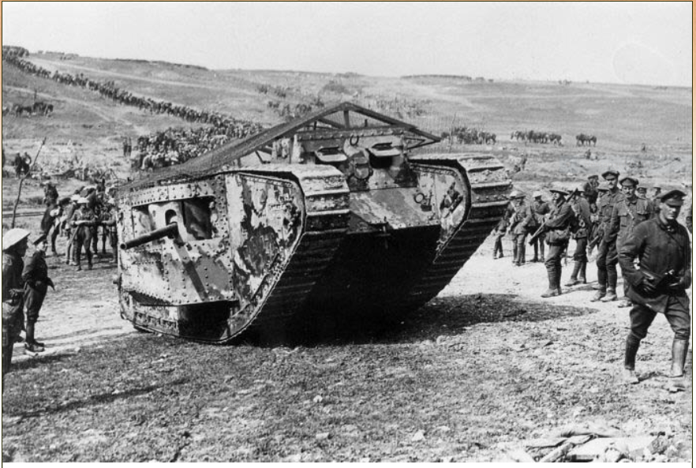
First Tanks Rolled Out

The British Generals in charge of both the BEF and CEF (British and Canadian Expeditionary Forces) determined it was important to continue relentlessly to wear the Germans down, so they sanctioned only a short hiatus between major assaults – only 11 days intervened between the Battle for Courcelette and the Battle of Theipval Ridge, which would take place on September 26th.

The Battle for Thiepval Ridge – Wilfred’s Final Day in Active Service

During the 11-day hiatus between attacks, the troops who would be involved in the assault were allowed to rest and to practice their assault maneovers. The 5th Battalion stayed in billets in Albert for most of this period. Immediately prior to the attack, on September 24nd, they were moved back to the chalk pits from their billets in Albert. And the day after that, they marched to the front line trenches to relieve the 7th Battalion, in preparation for the next day’s assault.

Tension must have been unbearably high those last 48 hours. For many of those men, Wilfrid included, this would be their first experience of going over the parapet in a large-scale, multi-brigade, entente-driven offensive. Their time had come to prove themselves as the aggressors in a major conflict on the world stage. In the 5th Battalion war diary for September 25th, the battalion commander states that “everyone is keyed up for it is what many have put in 18 months waiting for.”

That excitement is clearly communicated in Wilfrid’s letter to his mother written on the day before the assault, from the trench he would climbing out of the next morning. The scanned version of this letter is not very clear, mainly because the original, written in a trench in state of intense anticipation, was not all that legible. I’m also sure it was passed through many hands when it was received, so it’s now in a poor state:

“When I get back home I will be able to tell you the circumstances under which this letter is written. Tomorrow is going to be a big day in the history of the “fighting fifth” and the rest of the second brigade. I don’t suppose you will be able to guess what I mean but I am sorry that, on account of the censor, I cannot make myself any more plain except that by the time you have received this letter, we will have been over the parapet and at them. Now, there is no use worrying about me. I will send a “whizz-bang” [a military postcard with check boxes to communicate a soldier’s status to his family] as soon as it is over and you will know then that I am alright. I never felt better in my life than I do now,and am confident that I can hold my own when the time comes.”

The time came alright, and there’s no better description of it than the unusually florid and poetic description of the battle from the 5th Battalion War Diary. It’s very detailed and describes the events of the day with a precision which is very unusual for a battalion diary entry:

“The morning dawned clear and cool; there was very little artillery fire till about 11:30 a.m. when quite a lot of heavy stuff was fired into Regina Trench. The men had taken up their position during the night in the kick-off trenches and numerous shell holes and were all prepared for the signal. About 11:40 the artillery opened up and kept up a heavy fire in the front of and on the enemy works. At 12:34 p.m. the numerous machine guns placed behind our lines for creating a barrage behind Regina Trench opened up, and sharp at 12:35 the artillery opened up an intense barrage just in front of our men.

This barrage gradually lifted and the attacking force scrambled out of their temporary shelters and advanced close behind it [this is the famous newly developed tactic called the “creeping barrage” that worked every so much better than just walking slowly toward enemy machine gun and artillery fire and being mowed down by them]. The first objective was the Zollern Trench some 300 yards in front, and it was reached, taken, cleared and consolidated with very little trouble and quite a number of prisoners were secured and sent back, all of them helping to take our own wounded. The German barrage fire could not be said to have opened properly till nine minutes after the attack had been launched. During the advance quite a lot of sniping tool place and needless to say, no mercy was shown to the huns who kept that up till cornered, and then threw up their hands. By the time the first wave had reach the first objective, they had been thinned down considerably, but by the time of the third wave, consisting of the Mopping Up party reached the trench, the first and second waves had united and went forward as one to the second objective, which was the Hessian Trench….the casualties between the first and second objectives were very heavy and the number of men who reached the Hessian Trench were few indeed, but by 2 p.m. we had occupied and were consolidating this trench...D Company [this was Wilfrid’s company] on the left was some distance ahead of the right flank of the 8th battalion.”

I’m only quoting the first part of this lengthy entry because I believe that Wilfrid was injured at about this point. I’m basing my guess on his own description of what occurred, which you can find in the first letter he was able to write his mother, on October 4th. Again, that letter is not very legible and didn’t scan well, so I’ll quote his description of the attack in full:

“The good old Fighting Fifth lived up to its name and took all the trenches that was mapped out for it to take. I was just fifteen yards from our objective when I was hit, and the shelling was so fierce that I had to lay in a shell hole for a day and a half before I was carried out. My God! It was awful. But I am away from it all now for three months at least.”

When he writes to his sister, May, Wilfrid is a little more explicit: “The fifth were in the charge near Thiepval on September 26th. We went over at 12:30 noon. I got within fifteen yards of our objective when I was hit. I got a piece of shrapnel through the leg just above the right ankle...after being hit I was lying in a shell hole for a day and a half. It was awful but I was mighty lucky to come out of it with such a slight wound.”

In an even later letter to his mother, Wilfrid is even more specific:

I do not know whether I told you in my last letter the time and place that I got mine. Well, it was on September 26. The whole of the 1st Can. Division popped the parapet, or I should say, the 5th, 8th, 15th and 16th Battn’s went over with the rest in support. It was just alongside of Courcelette between there and Thiepval. We sure gained our objective and took a bunch of prisoners.

There are not that many photos from individual assaults, but, oddly enough, I found a photo labeled “Wounded Soldier Being Carried Out of Shell Hole After the Battle of Thiepval Ridge”. Wilfrid’s experience must’ve been very close (if not identical) to what we see in this photo – a soldier being carried out of a giant hole in the ground, filled with the detritus and remains from what I think was a German trench (the distinctive German grenade stick is one of the few identifiable objects among the litter of sandbags and general destruction):

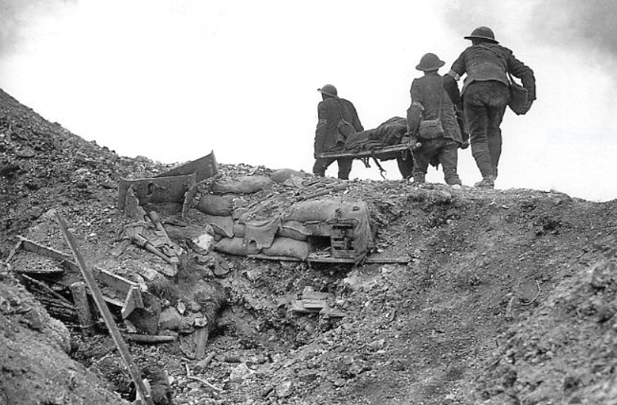

I also found this amazing night-time shot of the bombardments at the Thiepval Ridge Battle, which must’ve kept the sky lit up for Wilfrid as he lay in his shell hole in No-Man’s-Land.

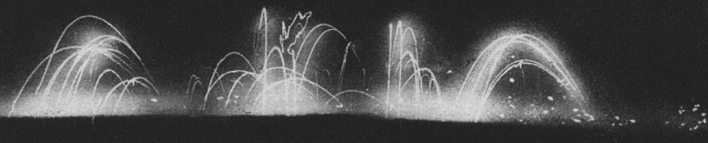

The assault that day (and night) involved the first Division attacking three separate trench systems: the Zollern Graben, Hessian and Regina trench systems. It would appear that Wilfrid was hit just in front of the first trench objective: the Zollern trench. Wilfrid was certainly not alone. As Tim Cook states, “The Zollern and Hessian trenches were attacked and held, but at a terrible cost. On the 5th Battalion’s portion of the front, 16 officers were killed, and of the ranks, 52 were killed, 291 wounded and 122 missing. Wilfrid’s name, directly after the battle, would’ve been among the missing.
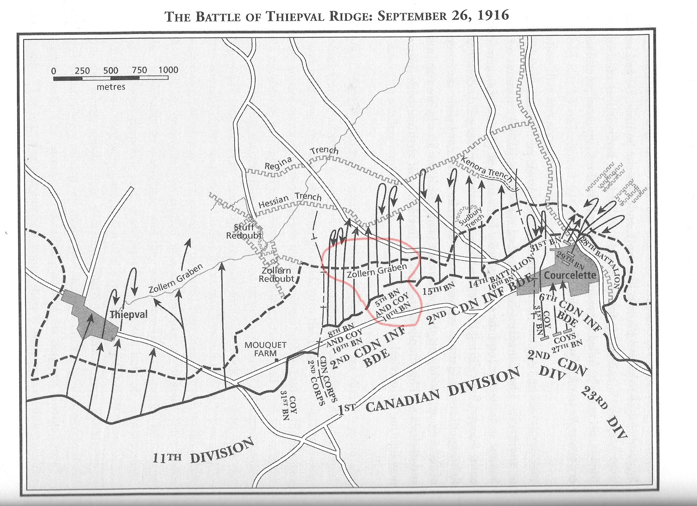
The Battle of Thiepval Ridge lasted another two days and was “a study in nearly unimaginable brutality. Attacks raged back and forth over the same shell-torn ground, with the infantry savagely fighting for every square metre of territory.”(Cook, 483) The battle was, apparently, only a partial victory because not all of the trench objectives were reached. One thing was very clear, though: the assault battalions were decimated, and those who remained standing were both physically and psychologically shattered by the ordeal.

Among the dead was a Neepawa boy Wilfrid apparently knew and mourned. His name was Hugh Gardner and he was killed in action on September 26th near Zollern Trench, where Wilfrid was wounded on that same day.

Wilfrid sent his mother a letter on October 22nd, a little less than a month after he fell, that included a rather touching postcard of a professional portrait of two soldiers, one of whom was Hugh Gardner.
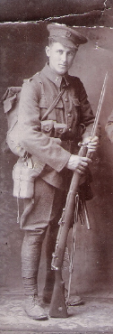
Hugh Gardner

This postcard must’ve been pretty special to Wilfred, as he sent it so his mother so she could keep it safe for his return. On the back he wrote the name and place of death for each of the soldiers in the portrait. Here’s what he said about Hugh:

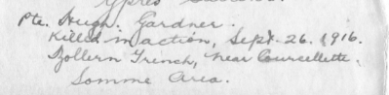
Hugh Gardiner (not Gardner, as Wilfrid wrote) had blue eyes and brown hair, and was two years younger than Wilfrid (just 21 years of age). Just like Wilfred (and most everybody else) he was a clerk (was there any other occupation for men in Neepawa?). Hugh had signed up in December of 1914 and so had been among the first contingent of Canadian soldiers to have sailed over to England in early January 1915. He had never been wounded or had a medical issue that kept him out of the action. He had been granted and enjoyed just one period of leave while he was in Europe. In early May of 1916, he was given 9 days leave of absence. But his luck finally ran out as he approached the Zollern trench that day in September of 1916 when his body was torn apart by bullets or shrapnel or both.

Reprieved from Hell: Wilfrid’s “Dear Sweet Little”, “Dandy Easy” Wound

Wilfrid’s luck held that day. In his first experience going over the top in a major offensive he was wounded in the leg, by a piece of shrapnel (or a bullet) that went clean through his right leg just above his ankle. The wound was sufficiently debilitating to keep him out of harm’s way for at least three months.

The Dunlop family was notified immediately via one of the usual “sincerely regret to inform you” telegrams that Wilfrid had been admitted to the Red Cross hospital in Etaples, France with a wounded right leg. Fairly soon after, Richard Buckley wrote a sweetly reassuring letter on the 28th of September to Nellie, informing her that “Wilfrid has been slightly wounded and is well on his way to England...George Fairbairn told me today is was a nice wound...You know we always feel like cheering when we know a friend of ours has gone to Blighty, as we call England.”

I suspect Richard asked George to write a note to Nellie as well, which he did (just as he had when Wilfrid had severe shell shock). This letter is very hard to read in its scanned form, as it was written on thin, almost transparent paper in pencil in a very tiny hand, so I’ll quote it at length here (spelling mistakes included):

Well, we have been in it nice and heavy lately. The old fighting fifth has lived up to all previous record. In fact excelled them. Wilfred, the lucky boy, got a beautiful blytie (sp). Which will give him a few months rest from this lively noisy life. He got a small piece of shrapnel in his ankle. One of the small bones may possibly be broken. All of us Neepawa boys sure envy him this trip to England. And he sure is a happy boy. He came into the Dressing Station all smiles and as his was a light case we had him in for most of the day clearing the serious as fast as possible. And believe me we were what you would call busy as we were dressing for about 12 battalions, all of which were in the big scrap. No doubt this time time you will have read all about it and Wilfred no doubt will send a full description. Don’t worry about his wound. It is a dandy easy one. I’d give him quite a bit for it as it may mean a winter pass to England. M.H. Smith joined our battalion on the latest draft from England and he also managed to get a piece of shell in his leg. Just had about 14 hours in the trenches. So he didn’t have to go through many hardships to get his blytie, eh? All the rest of the Neepawa boys in our brigade came through OK and will have something to talk of for years to come.

When Wilfrid finally was able to write to Nellie on October 4th, his mood is buoyant – and remains so for the entire course of his hospitalization. Having little to do but lie in bed and be looked after by pretty nurses clearly agreed with him. He begins the letter with an uncharacteristic exclamation of joy:

Hurrah! I got a nice “blighty.” I guess you have been wondering what kind of wound I got etc. and etc. Well, there is absolutely no need for worry. I am feeling fine and have a dear sweet little shrapnel wound over the right ankle. The piece went through – went in above the ankle and came out just below and in front of the ankle.

Typically, he can’t resist making a sneaky request for some cash near the end of the letter: “When I get out of the hospital I get ten days leave and it all depends on how much money I have that will make me decide on where I will go.” He concludes with “rest assured that I am in the best of health and spirits and am all tickled to death that I have been “safely wounded.” A final postscript asks mom to “send cigarettes as we get no money while in hospital.”

Wilfrid also mentions M.H. Smith in his letters, as being so luckily out of the war after less than a day in the front-line trenches. He was not that lucky, though, in his wound. Typically, it’s Richard Buckley who writes about “Smith” as he was called with more compassion. Richard writes from his furlough in England in April of 1917: “Smith came up from Eastbourne and stayed four days with us. It wa sjolly nice to meet him again. He looks very well in spite of his shortened leg, and has already learned to skip along quite spryly on his two sticks. I think we rather tiredd him out by taking him up and down the tubes when taxis were not to be had.”

The evidence of his letters suggests that Wilfrid enjoyed himself immensely in the Stoke-on-Trent hospital he was sent to. He describes making up parties of 5 to 7 patients and going out for “elegant” parties in which tea – or possibly something much stronger – was enjoyed at least once or twice a week. One of these so-called tea parties involved playing prodigious amounts of pool, at which Wilfrid apparently excelled. From these letters, we see a different side of Wilfrid – a sociable, garrulous and extroverted young man. He seems to have had the knack of making friends easily. We saw this in 1915, when he was newly arrived in England and in training. Then, he befriended both men and young women and pined for the money to socialize more. Within the town of Stoke-on-Trent (“the people around this city are dandy”), he met the Cowlishaws, a family with whom he kept up a close relationship throughout his long stay in England.

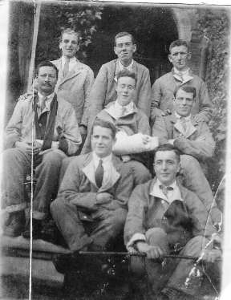
A Smiling Wilfrid (front right) with 3 Canadians,
2 Australians, and 2 “Imperials”

His elation at being freed from the wet filthy hell of the trenches and the constant threat of immanent death or dismemberment – and by what is apparently such a slight wound – is communicated most directly in his letters to his sister, May. The letters to his mother are more sober in tone, and I suspect she would not have approved of his being so overjoyed about his current situation. Here’s his description of a fun party in Newcastle in a letter dated October 20:

The people here are dandy. I was out to tea last Sunday with some very nice people and yesterday I was with seven others to a little party. We had an elegant time. All afternoon we played billiards and then sat down to a square meal. I won the snooker pool contest so I was entitled to the lion’s share of everything at the tea table and believe me I did not leave anything. It was the best meal I have had since I left home. Am going out again next Sunday. This is sure a great life. Beats France all to bits.

In the very next paragraph, his happiness gives way to survivor’s guilt. He writes about a letter he received from Richard Buckley, who told him that George Evans (“who used to work at the Hotel Hamilton”) had been killed and that Reid Howden and Charlie Thompson were missing. “It is pretty tough luck on the poor fellows and it makes me thinks how lucky I was. I thought I was hard pressed when I had to lay out in a shell hole in “no man’s land” for a day and a half before I was carried out but, after all, it was not so very bad, now that I am away from it all.” In a letter to his mother on October 16, he tells her that Richard Buckley “came through the Somme battles O.K. as the Canadians are away from there now. I am anxious to hear about the casualties. Some of my best pals were killed in the charge and there are others I have not heard about yet.”

One of those he was anxious to hear about was Stanley Rooney: “I hear Stan Rooney was wounded also heard he was killed. Which is correct?”

The two Neepawa men who had gone missing had mixed fates. As reported by Richard Buckley in his letter of November 13th, 2016, Reid Howden was among those killed trying to capture yet another trench (the Regina trench) after the Battle of Thiepval in early October at the Somme, just as Wilfrid was beginning his very enjoyable “blighty” experience of frequent tea and billiard parties, and dinner at the Cowlishaws with their very agreeable daughters.

Reid was another clerk (how could there be so many clerking jobs in one small town?) from Neepawa who joined up at the same time as Wilfrid and Richard (August, 1915) and was 21 when he was killed on October 10th. The official records for young men like Reid are distressingly lean and brief. Partly, this is because Reid had never been sick or experienced shell shock, so his records are bereft of information apart from the bare facts that he enlisted in August of 1915 and was dead in October of 1916. Unlike Wilfrid’s file, this one is short, terminating abruptly with the bald and pitiless statement that Reid was “previously rptd missing now rptd Killed in Action.” His father would receive his medals and decorations, and his mother would receive a memorial cross. End of story.

In the same letter, Richard describes Charlie Thompson’s bravery during that same battle:

Chas. Thompson was slightly wounded in our last visit to the Somme front. His battalion had a rough time and Charlie said he had extraordinary luck to come out as he did. Out of a crew of eight on his gun, he alone got through and though slightly wounded, he remained with his gun till his unit was relieved next day.

Continuing Convalescence
When first wounded, Wilfrid expected to be sent back to the trenches in about three months. He also expected to leave the hospital and be sent to a Convalescent Camp at the end of October. However, his wound did not heal with the rapidity of the originally optimistic prognosis. Instead, his foot became dramatically swollen when he got out of his bed and began to crutch around the war.

Well, here I am back in bed again. Got up for a day or two on crutches but my foot all puffed up again. Either one of the small bones, on the outside of the leg just above the ankle [likely his fibula] is broken or the tendons are torn away and bones are out of the sockets. However, they are going to put it underthe X-Ray and will know more about it then. In the meantime it is very painful abut that does not alter the fact that it is a dear, sweet little wound becauseit will keep me away from the firing line for at least three months and maybe all winter.
Nearly six weeks after the wounding, in early November, Wilfred’s letters became more dispirited as he writes that he will have to remain in the hospital for the foreseeable as his wound is not healing as well as expected.

Am still in the same old place, although, over a week ago, I was marked ready for convalescent. However, during the past week, my wound has been giving me considerable pain and is not healing as quickly as it should. If it does not improve iwthin the next week I fear I shall have to undergo an operation as the doctor thinks there may be some dead bone in there that will have to be fixed.

Despite the fact that his wound has become somewhat less “dear” and “sweet” as time has passed, Wilfrid’s good humor remains intact:

Was out to tea again yesterday and had a fine time. By jove! There sure are some fine people around this place. They will do all they can for the wounded. It helps a lot you know, especially with those so far away from home. I am going out to tea again on Sunday...It rains every day over here but believe me it is a million times better than France. I am not at all anxious to leave here, it is a dandy place are the sisters are A1., but I guess I will have to break away some time. I certainly have had a fine time since coming her and hope that when I go to Convalescent the fun continues.

Then in the third week of November, the wound took a turn for the decided worse, with septic poisoning entering the clinical picture. He assures Nellie that this turn of events is “quite common in the case of shrapnel wounds. Despite this, he remains confident that he’ll be sent to a convalescent hospital soon. In this same letter of November 18th, he writes that he’s had sad news from France about his Company from his Sgt-Major:

When the Company came out [of a charge/assault] there was only 32 men left [the pre-charge number would have been anywhere from 100-150]. A lot of the lads who just got slight wounds, while we were in the charge, were in too big a hurry to get out to the dressing station and on their way out were blown to bits by shells. Well, when I got hit I crawled around and found a good shell-hole and stayed in it until the heavy shelling ceased. I was in it for a day and a half but that was better than being blown to bits, eh!!!

Despite this sad news, Wilfrid’s implacable cheerfulness cannot be suppressed for long. The very next paragraph is about another pleasant social engagement at the Cowlishaws’ and ends with a jokey reference to how healthy he looks now. Some might call this insensitivity, but I prefer to think of it as the strong Dunlop tendency to make other people laugh, even if it’s at the expense of others (or oneself):

I will be enclosing some more snaps in this letter that we had taken at Mrs. Cowlishaws’ last Monday. I guess when you saw the last one, you said to yourself, “The poor boob doesn’t look very sick!”

A letter a week later suggests that he will be sent to Convalescent immanently, but the main news is that he has received a letter from his papa! And it contained a money order for $20.00: “I received father’s letter this week with a m.o. for $20.00. By the powers, I have been kicking my heals (sic) up ever since. It sure will be a big boost for my ten days leave.” So much for the family myth that Wilfrid was totally ignored by his father throughout the course of the war! In the same letter, Wilfrid talks about what “good sports” the three ward sisters are: “I have a good stand in with them all and that makes it all the easier for me.” It’s easy to imagine that Wilfrid, with his easy-going, handsome demeanor and his jokey, teasing cheerfulness, must have been a well-liked patient – not unlike his son, Robert, who could never resist teasing and making his nurses smile or laugh when he was in hospital, as he frequently was in the final years of his life.

November gives way to December, and when we next hear from Wilfrid, he’s still in same Stoke-on-Trent hospital, and happy as can be about it:

Well, here I am still in the hospital. However, I am in no hurry to leave as I like it very much and am certainly having a grand time. I have received three letters from you this week, also three copies of Life magazine and two big boxes of cigarettes. Pretty good for one week, eh? I am might well supplied with cigarettes now and am feeling fine so why should I worry???

William Miles: Another Irish Orphan
But news of the Neepawa boys in France just kept coming. Nellie keeps herself busy sending parcels not just to Wilfrid but to many other Neepawa soldiers as well. She receives a letter from William Miles, who, like Richard Buckley, was a young Irish immigrant who signed up at the same time as his friends, in August, 1915. And, you’ll be shocked and surprised to learn that he was a clerk! Clerical workers were clearly a major part of the Neepawa workforce. Unlike Richard, he was an actual orphan (Richard’s parents still lived in Ireland), whose only relative was an Aunt living in London, who was also named as his beneficiary should he be killed in the field.

Unlike Richard’s extravagantly well-mannered, almost courtly letters, William is plain spoken (“thank you for the “box” you mention which I guess will arrive in due course”) but just as informative as Richard when it comes to the fate of other young Neepawa soldiers.

Am glad to hear that Wilfrid is having such a good time in “Blighty”; it will do him a world of good and he certainly deserves a rest. I don’t know how I managed to go through the same ordeal and never received a scratch. This front which we are now holding is rather quiet for a change. The weather, though, is very wet and cold, our trenches are in an awful condition.

I will gladly remember you to any of the Neepawa Boys I happen to meet, although George Fairbairn and I seem to be the only two left in this Battalion (the 5th).

William was a bit of a star – and he clearly had a lucky one looking over him. He was never wounded, even though he was only out of the war for a few weeks for some officer training and then he was sidelined to England to recover from tonsilitis, which was a serious disease in those pre-antiobiotic days. William distinguished himself with his attention to duty, and was rapidly promoted, first to Lance Corporal, then to Full Corporal and finally to full Sargeant.

This represented the kind of military career trajectory that the Dunlop family likely expected from Wilfrid. But, for reasons that will become very clear as we continue to explore his letters and his records, Wilfrid came close on a few times to permanently moving up to officer class but his weaknesses (his character flaws, if you like), his love of an easy life and his lack of ambition trumped every attempt to better himself while in service.

In this same letter of December 7th, William Miles commiserates with Nellie over the death of a young Neepawa soldier named Sedley Monnington – an unusual name for a young man with an unusual occupation as well. Not only was he not a clerk but he was, of all things, a professional musician. William wrote:

Yes, I was surprised when I read about Sed Monnington’s death. His family must feel the loss immensely.

Nellie must have mentioned Sedley’s death in her previous letter to William, as he is here responding to the news she sent him. Nellie must have felt really terrible about this young man’s death, as she also mentioned it to Wilfrid. Wilfrid’s response on December 8th is blunt, cold and lacking in anything like genuine pity:

It was too bad about Sed Monnington. However, he had to take his chances the same as the rest.

Almost in the next breath, he talks about how well and generously the sisters are treating him as he suffers from a “nasty cold”, giving him “a jug full of hot lemonade and brandy, four aspirin tablets and a hot water bottle.”

We have to note again in passing the relative coarseness of Wilfrid’s feelings for those other than himself. Sedley Monnington died at the age of 22 during a Somme assault from gun-shot wounds he received to his head, arm and buttocks. He was the only son of a large family composed mainly of daughters . Born in 1858, his father, James Henry Monnington was a well-known and loved pioneer in the area, having actually paved the main streets of Neepawa in its early days. He lived to the age of 92, no doubt having mourned his only son for over three decades, and then was buried in Neepawa’s Riverside Cemetery in 1950. Young Sedley was buried in the Contay British Cemetary in the Somme area when he was one month shy of his 23rd birthday.

Meanwhile, Wilfrid’s cushy life at the hospital went on much as usual, each day, though, bringing a fractional increase in comfort as he continued to charm the sister nurses and help them with their duties. Here’s a lengthy description he wrote to May of the ease and comforts he enjoyed:

In all probabilities I will be here [at the hospital] now for Xmas. I hope so any way as I am sure to have a good time. The sister who used to be in charge of our ward has been promoted is now the night superintendant. I sure had a good stand in with her and every morning now about four a.m. she has a cup of hot tea and some toast sent in to me. This morning she sent me in some home-made mince pie. Some life this. What think you? Is there any reason why I should want to leave here in a hurry?

When writing to Ruby, to whom he was closest in age (she was his little sister), Wilfrid could be quite funny. This from a letter to her just before Christmas:

I have about “umpteen” invitations out to Xmas dinner and I think I will accept them all so that I will be sure of getting a square meal. I certainly am going to have a big time. Give my regards to all the natives including “Wanshau du Panchau, Esq” [the family dog] and don’t forget to write soon and often.

Wilfrid’s xmas wish came to pass: He got to stay in his beloved hospital over the Christmas season. There we find Wilfrid in top form and at the peak of giddy happiness and pleasure. He writes to his mother on Christmas day: “Well, this is Xmas day and a vastly different one to what I spent last year. Gee! But I have had a great time:

Did I tell you about the bets I had with the 7 sisters about catching them under the mistletoe? [Wilfrid had bet each nurse one dollar – no small sum in 1916 – that he would kiss them on Christmas Day) Well, I won them all. I suure have caused a sensation around the hospital. I certainly have had an exciting daychasing them up and down the stairs with a piece of mistletoe in my hand. They have nick-named me “Flirt”.

Wilfrid’s comfortable and easy hospital life would soon come to an end. In the closing days of 1916, Wilfrid would enjoy his last few days of repose and indolence, and, although he would never enjoy such ease and freedom from care again, he would never have to return to the battlefield. He enjoyed being a patient, and had a full three months of it, but he couldn’t remain one forever. As he told his mother in a letter dated Feb. 4th, 1917, “I have had no pass whatever since October 1915 and we are supposed to have a pass every six months. However, my three months in hospital made up for the lack of holidays as it was just one long joyful holiday in itself.”

Medical Board Declared Wilfrid Unfit for Active Duty

The Medical Board met on January 15th, 1917 and declared Wilfrid unfit “for further active service in France” and was waiting to be posted to the Canadian Army Pay Corps (C.A.P.C.) Paymaster’s office. The judgment of the board was based on this summary of his present condition: “Bullet entered leg from behind about an inch above right ankle maleatus. The wound is scarcely healed with redness and swelling over entrance.”

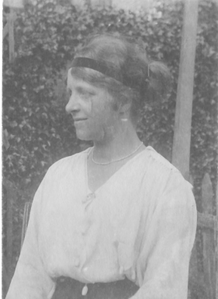
Wilfrid describes the episode to his sister as follows: My transfer to the Canadian Army Pay Corps is now pending. This means that I am now “bomb-proof” for the duration and do not have to worry about France or loousy dug-outs or fleas or rats and all other kind of miserable vermin. I have had my fill of all that. I still have some of the scars on my body yet from louse bites. They are fine little souvenirs of the war but the best scar of my wound is the best of the bunch. When I went before the Board they took a look at my wound and that was enough. There is a growth on the bone that is a hard swelling about the same size as my ankle.”

He wrote his mother with the same news, adding that the swelling “could be easily fixed if I undergo an operation but that does not appeal to me as I would be all right after it and would have to go back to France whereas by leaving it as it is I am “bomb-proof”. So there is no further need to worry about me having a “Jack Johnson” bounced off my bean.

With the new freedom of the typewriter, we find a much more jocular Wilfrid. A “Jack Johnson” was WW1 slang to describe the impact of a heavy, black German 15-cm artillery shell. (Jack Johnson (a black man) was the then-current heavyweight champ.) Wilfrid also states, “I tell you after my experiences in France I sure do appreciate a decent job once more and believe me I am going to hang on to it.” This suggests that maybe he had trouble, not only with debt, but also with keeping a job. This is reinforced in his next letter to May in which he states “All I want now is for the blooming war to end so that I can get back to Canada and settle down. No more wandering around for me. I have had enough of it this last two years. I will be quite satisfied to get a good job and stick to it.”

Early Days at the Paymaster’s Office

In early January, Wilfrid wrote a lighthearted and happy letter to Nellie to say he was out of the hospital and at the C.C.A.C. (Canadian Casualty Assembly Centre) in Folkestone, awaiting a medical board review of his case. This review would determine his degree of fitness and basically where he would be most suitably deployed in terms of his physical abilities. The options are only two: “light duty (with the C.C.A.C.) or “back to France with the best of luck.” His current job was doing “clerical work in the Paymaster’s Office,” a job he was well suited for, given his previous experience in this line.

A few days later, he wrote to Nellie again. I quote this letter at length as it was written on legal-sized paper which will not scan well:

I bid fair to be here for some considerable time. I have evidently made a good impression with the Paymaster, as he told me this morning that as soon as th emedicla papers of my case came through he would arrange to get me my board [his medical board review] and see what he could get for me in the way of light duty. This sure is a dandy job and I have been working might hard to make good. It was awkward for me, ast first, to get accustomed to office work after a wild life for a year and half. However, I think I have managed it alright.

Wilfrid’s Scheme to Defraud the Government

Money worries and schemes to get some continue to obsess Wilfrid, mainly because the army held back half of every soldiers’ pay (amounting to twenty dollars a month) to be paid out at war’s end. This was okay in the trenches where there was nothing much to spend money on, but for those in England, this was much less workable. If the soldier had a dependent (typically a wife or child), this money would be sent directly to that dependent rather than be held back. So….Wilfrid declared that his little sister, Ruby, was his dependent so she could receive every dime of that previously held-back money (around $200) and have the ongoing $20/month sent to Ruby, who would then forward it to him. He had originally declared that his older sister May was his dependent, but with her being a married woman, the officials determined he was trying to put one over on them. He states that he was “going to declare black and blue that she is an orphan or something and is absolutely dependent on me. I will get ahead of the old sinners some way.”

Wilfrid’s plan to get his “remittance” – his withheld backpay to the tune of $200. – didn’t work. But he did manage to get his ongoing monthly half-pay assigned to Ruby (whom he nicknames “Oose”) – which would then be sent on Wilfrid to help him meet his expenses. He ends the letter to Ruby of February 1 that explains all this with a somewhat baffling reference: “How is the “CHESTY DEEG2” getting along. Does he still stink as much as ever?” This must be the family dog, that Wilfrid clearly adores and whom he always references in his letters home...He must be very homesick, as he hauls out all kinds of endearing nicknames for the dog. In the previous letters to Nellie, he had asked after the “Pyaucha Pyup,” “Wausha de Paucha,: the “brown fool” and “byaby pyup”. I think “CHESTY DEEG2” must have been Ruby’s toddler talk from bygone days for dog, but I’m really only guessing, of course.

Wilfrid and Ruby (a.k.a. Oose)

Wilfrid certainly seems to believe Ruby (nicknamed “Oose” by Wilfrid) was slightly childlike in her powers of understanding. In a letter he wrote to May the very same day, he suggests Ruby may not completely understand the scheme, and that May should speak to her soon to clarify it: “You might tell Ruby when you see her again just what to do in case she does not understand.”

Ruby’s lowly status as the youngest is reinforced here and there in the letters. For example, Wilfrid’s homesickness prompted him to beg his mother for photos from home, once asking “Have you anymore snaps that would be of interest? Would like some. Send Oose on the hunt for some.”

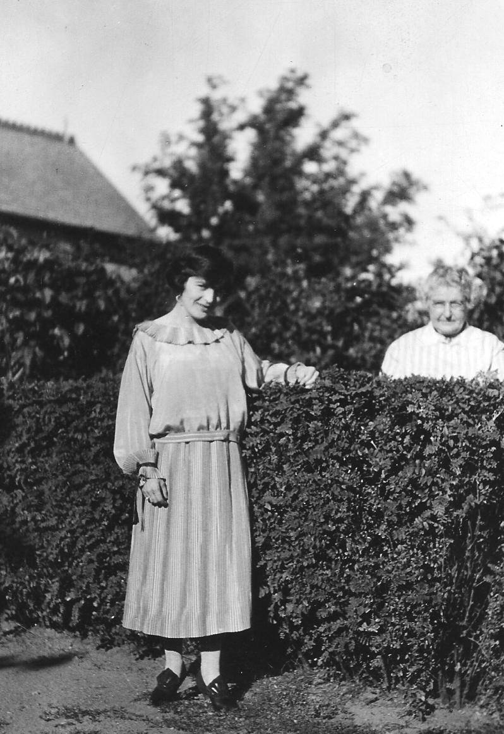
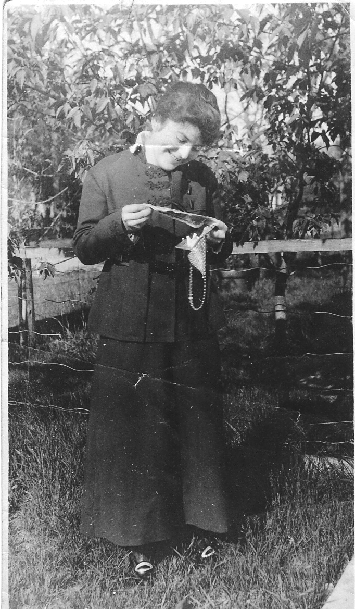
Ruby Dunlop --a.k.a. Oose

He often refers to her silliness when he writes to May: “I got a particularly giddy letter from Oose yesterday. She says she met a gink who works in Stovels by the name of Bannerman. She says he is a cute kid and a dinky mustache, etc & etc.”

Wilfrid Loses his Sargeant Stripe – His Aversion to Being an Officer

Wilfrid was a “sometimes” sargeant. He claimed in a letter of Feb. 2, 1917, that he needed to “take down” his stripe in order to transfer to the Canadian Army Pay Corps (C.A.P.C.). As we shall see later on, this extra stripe would come and go with instances of Wilfrid working hard (gaining the stripe) and Wilfrid being naughty (two drunk and disorderly charges which meant losing his stripe). At this time, however, it seems clear that to take the clerk position at the C.A.P.C. he believed he had to be demoted to the rank of Private.

I figure it is worth it to be sure of being safe for a while anyway. I have had my fill of France and believe me I am only too glad to do anything to keep away from the darn place in future. However the stripe was the least of my worries anyway.

However, in his medical board review, he was classified as C3 which means just one thing: “Sedentary Service at Home Camps.” While he suggests that officer status would somehow jeopardize his cozy desk job, raise his profile and make him somehow fit for active service again, we have reason to be skeptical. His letters, as we shall see more clearly soon, were not always 100% truthful. He may have been somehow averse to assuming the greater responsibilities that attended officer-class work in England. He may also have been resolutely determined to never, ever return to the battlefield (and who could blame him) and felt remaining a private would keep him well under the radar of official notice, and so would more conducive to staying in England for the duration. He appeared to have a running and rather bitter battle with his sister May on this very issue:

You seem to be quite take up about Percy Kerry getting a commission. Well, let him get it. That does not make him any better. Lieutenants get killed just the same as privates, and, believe me, I would just love to see that same boy over in the trenches during a heavy bombardment such as we used to go through many times during our stay at Ypres last summer. He sure will get his eyes opened when he gets over there, ifhe ever gets up enough spunk to go. It would be a comparatively easy matter for me to get a commission but there is rather a big expense attached to it while attending the Officer’s Training School...I guess I will be just as happy going through this war as a private as I would be as an officer.

In the next letter to May, he actually seems very defensive about not being a combatant any longer. He writes about something major about to happen on the Western front, “and I am very well pleased that I will miss it all. I have had all I want of it and am quite willing to stay behind in England. There are plenty of fellows over here who have never yet been across the channel and who have been in the army longer than I have, so I figure it it is up to them to get out there and do something for a change. I wonder if Percy Kerr every got over?”

I Do Like to Be Beside the Sea Side!

His new job was with the Divisional Paymaster’s Office, Farley House, Sandgate. I found this old photo of the building – which is right on the seaside-- on the Web:

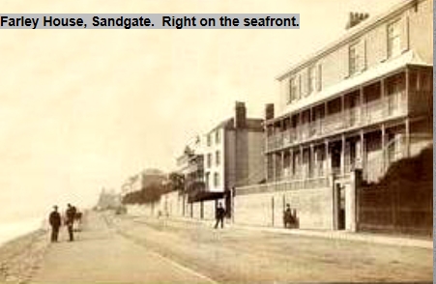

In a letter to May, he says “The house is situated right on the coast of the channel. It certainly is a very pretty view and I should imagine it will be a lovely place in the summer. I guess I have a pretty good time ahead of me for this year….We have a lovely office here. The whole side is one row of windows and looks right out on to the channel.

While Wilfrid expected to stay at Farley House for the summer, he was hoping to be transferred to the C.A.P.C. (divisional paymaster’s office) in London. But, just as he was winding down his work at the C.C.A.C. (Casualty Assembly Center):

...the Quarter Master came around and warned us all that the building was placed in quarantine on account of measles and that none of us could leave the place for sixteen days. Well, sixteen days did not look very good to me so I climbed out the window and went down and reported to the Paymaster, who was at his home at the time. He said I did quite right so on Monday morning we moved our office and I am now attached to the Divisional Paymaster’s Office.

This sounds like something his son, Robert, would’ve done. We see the same kind of daring and risk-taking behavior and a delight in snubbing authority figures.

It’s also interesting to note that in the same letter, he tells his mother “I am going to be gazetted as a sergeant very shortly according to what the boss says so I am not losing anything by the transfer.” So much for the story of the requirement of him being a private for taking the clerical job! He lives in hopes of this transfer to London, the “main reason I want to get up there...is that we live in private houses and --gee – but it will be nice to get back to a feather mattress again.”

Richard Buckley wrote to Nellie in the spring of 1917 while he was in England, and, since he no longer needed to worry about military censors, he was not shy about commenting on the progress of the war:

We had such good news today from France, over six-thousand prisoners taken in yesterday’s fighting and the Canadians succeeded in taking Vimy Ridge. We are doing great things in a quiet way. With the U.S. in with the Allies, the war should not go on much longer. The fighting seems to be reaching the climax just now, and the artillery fire which opened yesterday’s attack is said to have exceeded any previous bombardment in intensity, and the aeroplanes make war on each other almost like infantry. The tanks are again included in the engines of war.

“It Sure is Fine to be Living in a Civilized Place Again”

Wilfrid’s transfer to London to work in the C.A.P.C. Chief Paymaster’s office comes about in early April, and he’s ecstatic to be living in an actual HOTEL (the Shaftesbury on Great St. Andrew’s Street- “285 bedrooms fitted with h. & c. running water in each. Telegrams: “UNAFRAID”, LONDON”) so he can walk to work. His office “is right close to the Parliament Building and the Abbey.”

He made a project of visiting the tourist sites, including the zoo at Regent’s Park, Westminster Abbey and Hampton Court. He even had a date with a London girl he’d met in 1915 (he tells his sister of this but only mentions the outing – not the girl – to his mom).

Despite outings with girls (or one special girl, as was speculated by his son Robert), it doesn’t take long for the bloom to disappear from the London rose.

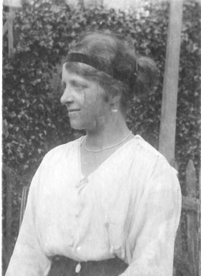

Photo of “Wilfrid’s British Girlfriend” (According to Bob Dunlop)
In only a few weeks, Wilfrid came to believe that Neepawa – not London – was the acme of civilized living, and all because of imposed rationing of food. On April 27th, Wilfrid writes a letter to his mother that’s full of extended complaints about the availability of food in England:

They have cut down the rations over here again...For instance every Tuesday is a meatless day. No meat of any kind can be had. Then again only two days a week are set apart when you can have potatoes. For breakfast, dinner or supper you are only allowed two very small lumps of sugar no matter how many cups of tea you have. No pastries of any kind can be had if you have a slice of buttered toast with your meal you cannot have a slice of bread. Only one slice of bread per meal. It is worse here for restrictions than it was in France. Sugar is a luxury surpassing what champagne used to be. It sure is rotten not to be able to get a square meal when you are hungry. No meal must exceed two courses except between 6:30 and 9:30 p.m. when three courses can be had. I sure will be glad when I can get back to a civilized land and have a square meal once more!

In the same letter, Wilfrid remarks that he has “a chance of a commission” but will ignore it because “officers are in great demand over in France” and he has no intention of ever returning to the horrors of the battlefield.

Wilfrid’s Letter-Writing Duplicity

We’ve had hints of it before, with Wilfrid writing one version of events to his mother, and a different version of the same events to his sister. But now we can put letters he wrote to his mother side-by-side with those he wrote to his sister and read two very different – even contrary -- views of the same events.

He writes to May at approximately the same time as the April 27th letter to his mother. In this letter, he states quite baldly: “I am getting three stripes in a very short time.” He could write this on nearly the same day as he wrote: “I have a chance to take a commission but I have no thought of doing so at present” to his mother. He certainly was going to get his “three stripes” (promotion to sargaent) but it would be as a Non-Commissioned Officer (NCO), in the form of a temporary appointment.

We know that May had been strongly encouraging Wilfrid to work towards obtaining his officer commission. Why she was so inclined we can only speculate, but Wilfrid’s justification for not seeking leadership roles is a constant theme running through the letters to May. At this time, Wilfrid was desperate for money. He states that “I am hoping to get a letter from you next week. I am thinking that some of that assigned pay will be along with it. I hope so anyway as I could certainly do with it. It is rather expensive living up here as everything is so dear.” His assurance that he was just about to become a Sergeant was pretty clearly an attempt to get into her good books and loosen the purse strings.

At this time (in his letter of May 5) Wilfrid received a letter from papa, which was the second or third reference to Alexander writing his son a letter, destroying the family myth that Alexander never once wrote to Wilfrid during the war years. He states that papa wrote that Nellie was ill, which clearly troubled Wilfrid. He asks: “What was the matter? The old spring trouble?”

He inquires after his mother’s health in a letter written at about the same time to May, so it was very much on his mind. He writes to let May know that “I received your letter with the big money order in it.”

Now, About the Commission

Having got the funds he had sought, Wilfrid finally levels with his sister, and there’s a genuine tone of defensiveness in the letter:

Now, about the commission. I have been thinking this thing over as I can very easily be recommended for one if I feel inclined to take one. However, so long as I am classed C3 (medically unfit for active service) I am satisfied to stay the way I am...You want to know why I am now only a buck private. Well, here is the reason. Any man holding stripes and transfer to the C.A.P.C. (paymaster’s office) must revert to the ranks and come as a private. Well, I was rather proud of that stripe but I was not going to let it get in the way of getting a soft job so I agreed to take it down, knowing that if I made good at the work I would be made Sergeant in due time.”

May’s insistence on Wilfrid becoming an officer is a continual refrain in these letters. She clearly felt it downgraded the family’s social status within the town, as she often writes to tell him of other Neepawa boys who obtained commissions in an effort to shame him into acquiring more ambition in his military career.

Wilfrid references a question she posed in a subsequent letter written in late May: “You asked me if they were in the habit of transferring us around from one branch to another also if my move up to London was a promotion.” This, together with what must’ve been continual harping on his lowly status as a Private, suggest that May was very focused on a perceived lack of ambition on Wilfrid’s part, and communicated this clearly in her frequent letters.

The pressure from home to work his way up in the ranks must’ve been a source of great stress. His main aim after recovering from his wound was to stay in England, at all costs. And, if this meant remaining a private, it seemed a small price to pay for the privilege of never again entering a trench. He made it very clear that pursuing an officer’s commission (through a lot of training) would very quickly land him back in trench hell, and that was a place he would never willingly return to.

Also, the business of rising through the ranks was slightly complicated by the fact that temporary promotions had become the norm. It was very common for men who held the rank of Private to be given temporary promotions because of a shortage of commissioned officers to fulgill the role of sargaent or corporal. These acting ranks were given and taken away as the need arose, and there were no negative connotations when a man with a rank of Acting Sargeant or Corporal was required to surrender his rank as circumstances changed – and this typically occurred when a soldier was moved elsewhere. In none of the letters does Wilfrid attempt to describe the difference between a permanent and an acting rank. He simply states that he has been promoted to Sargaent, for example.

The records show that Wilfrid’s permanent grade – the rank he held thoughout his military career --- was Private. We also know that Wilfrid was made “Acting Sargeant with pay of rank” in December, 1917, a few months after he moved from his clerking role at the Paymaster’s Corp in London, to the Canadian Army Medical Centre at Bramshott.

As an NCO, receiving “pay of rank” would have been a very big deal indeed. Privates only received $1.00 a day, not much even by 1917 standards, but Sargeants received a 50% increase, receiving $1.50 a day. And why on earth would you go to all the trouble of pursuing a commission to get the higher rate of pay you could quite easily get by accepting a temporary appointment – and without the risk of being sent into battle again.

Clerk Extraordinaire

Just as soon as Wilfrid got himself his first clerking job in England, he started typing his letters. They’re evidently typed with genuine expertise and fluency. Wilfrid’s evident skill with the typewriter (a skill acquired at his father’s press?) must’ve made him an absolute standout.

Clerical work was a very common white-collar job in those days. As many as 18% of Canada’s expeditionary force attested to being “clerks” when they joined up, but, of those calling themselves “clerk,” only a small number would be capable of typing with any degree of proficiency. In Canadian offices, writing by hand in ledgers was the norm. Typewriters were very expensive (about $100) and were not yet standard equipment.

I suspect Wilfred was exposed to the then high-tech world of mechanical typing at his dad’s press. Regardless of how he acquired the skill, it would certainly set him apart, and typewriters were more likely to be found in English offices than Canadian ones. Anyone with typing proficiency in the CEF would be in demand:

I can get an escort trip whenever I want one but then I cannot always spare the time away from the office. It would be different if I had someone in the office who do the typewriting. (Dec. 30, 1917)

This suggests how highly valued Wilfrid’s typewriting skills were, and how he may have even owed his life to his skills at the keyboard. I suspect Wilfrid was encouraged to remain in a clerical capacity even after his leg no longer prevented him from returning to the trenches, his typing and office skills may have been prized sufficiently to keep him safely in England even after he was declared fit again.

Just before landing his most responsible job (orderly room clerk with potential for becoming the staff Sargaent), he writes to May, saying: “the colonel wants me to stay on, as all the men on the staff at the hospital are being returned to the depot to train for France and they are going to be very short of efficient help.”

Indeed, in September of 1917, when Wilfrid’s 5th battalion was smack dab in the middle of one of the most horrific engagements of the war, the Battle of Passchendaele (a.k.a., the 3rd battle of Ypres), Wilfrid was declared fit for active service. But by some miracle, Wilfrid was spared from returning totheYpres hellscape he knew all too well.

In a letter to Nellie dated September 15th, 1917, Wilfrid reports that thing he had feared so deeply – being declared fit to return to active service – had just happened:

I have been classed as fit again but am being transferred out of the infantry into the Canadian Army Medical Corps. I do not know what the idea is but I suppose it shall be better than back at my unit.

In the same letter, and in several more afterwards, he writes about applying for an officer’s commission. These were placatory letters, written to keep his family sweet. The subsequent letters to the Dragon-Lady sister, May, go on rather a lot about how expensive it will be to attend the Cadet School, buy the cadet uniform and kit, etc. – all to pursue the commission the family is so keen for him to obtain.

There was likely a pecuniary interest in going through the motions of becoming an officer. As long as he kept May’s hopes of his becoming an officer alives, she would cable him the occasional cheque. Whenever he received one of these cheques, he would take time off on leave and assure May that he would be “having a grand time” thanks to her timely remittance.

Life at Bramshott

Wilfrid would’ve enjoyed staying on in London at the Paymaster’s Office, but, once he was declared fit in September, 1917, he had to leave “the infantry” and join the Canadian Army Medical Corps in Bramshott.

Wilfrid disliked Bramshott. He said, “I was down to Bramshott about a month ago on duty and believe me it is an awful hole.” At the time, he thought he’d be posted elsewhere with C.A.M.C.: “I am glad that I shall only be there a very short time.”

But it was to Bramshott Wilfrid was posted, specifically to the No. 12 General Hospital (Annex), where he was assigned to work at clerical duties as a member of the office staff. That “short time” became, if not the remainder of the war, at least the next year of service.

Once again, he declared his intention to go through for a commission in the Imperial Army, but, in October, the Canadian Army medical board rescinded his “fit” designation and put him back to “C3” category – which means he was again considered fit only for a desk job. He asked to be brought before another medical board, but reports in a later letter of October 28th that the board “raised my category up a few notches to B1 but still I am not classified as fit.”

By the end of October, he largely gives up the quest for a the commission and resigns himself to the mundane routines of his new job in the Orderly Room at No. 12 – routines that he seems to have rather enjoyed.

Promotion and Other Successes
Despite the occasional bout of despondency, he soon had cause for more optimism. His organizational and typing skills were recognized, and by November of 1917, Wilfrid was promoted to Sargeant Clerk and put in charge of the orderly room. His letters indicate that he worked long hours and relished his position of responsibility.

...I have at last got my promotion to Sergeant. I have been put in charge of the orderly room and taking things all round I have a splendid job. I have a spring bed and mattress to sleep on. We are fed very well indeed at the Sgt.’s Mess and a little increase in pay helps to make the darned old army worth while. (November 9, 1917)

It wasn’t long before Wilfrid was rewarded with a promotion to acting Staff Sargaent, with pay of rank – the highest acting rank that a non-officer could reach.

Wilfrid’s letters from this period indicate that he thrived on the work (he excelled at clerkly duties, including typing – we note all his letters were typed with great proficiency) and enjoyed many privileges such as leave for travel.

When writing to May, he still referred to Bramshott as an “unearthly hole” but seems to be generally happy with this situation – and sometimes even ecstatic. There are frequent references to a certain “Mrs. Cowlishaw” and “one of her daughters”, both of whom send him letters and invitations to visit them at Stoke on Trent: “You can bet your bottom dollar I am going to accept!”

1918 Malcontent: Increasingly Restless

Although largely content with his promotion and hospital clerical work, by early 1918 we hear once again, the letters reflect a growing restlessness. He writes to his mother in January of that year: “I shall be satisfied to stick right here for the duration. I have a dandy job and everything else about it is all that could be wished for….but sometimes I feel like asking to be marked fit and go out to France again and have it out one way or another, either get so badly knocked about that I will be useless to the army or get the other thing.”

Wilfrid had been away from home for three years now. His impatience with army life and what must’ve been stupefyingly dull clerical work at Bramshott hospital becomes more obvious. He even betrays a rebellious streak to his “dear mother” which he would’ve carefully hidden in the past. In the same letter as above, Wilfrid declares:

I do not wear my good conduct stripe now as it is only to be worn by those junior to the rank of corporal...If I stay in the army for twenty eight years and behave myself all that time, I shall be entitled to wear four of them???????????????????????????? a fellow deserves a million of them if he behaves himself in this army for that length of time.

The same day (January 11, 1918) Wilfrid wrote a letter to his sister, May. The main purpose of that letter (as were most of the letters to May) was financial, to underscore the importance of sending him money ASAP so he could enjoy his upcoming 4-day leave in London. However, he also mentions a very tempting invitation to spend a few days with Mrs. Cowlishaw (she with the lovely daughters) – which he had not mentioned to his mother. He also thanks her for sending him his favorite magazine, Redbook. At the time, Redbook was not so much a woman’s magazine as it is today but “"the largest illustrated fiction magazine in the world" with fiction by Jack London, Sinclair Lewis, Edith Wharton, etc. Stories were about love, crime, mystery, and the old west.

His letters became much less frequent in 1918 – and he writes much less to May than he did. Only one more letter was sent in January of that year,to his mother and, despite its initial cheerfulness, Wilfrid again betrays a desperate impatience and discontent:

I suppose the war will still continue to run on the same for another year. If it does not take a change very soon, I am going to try for furlough to Canada. I wish papa would put in an application from that end to ottawa to get me three months furlough on compassionate grounds. Other fellows are getting it that way. Why cant I?

In his letter of February 4th, Wilfrid reflects on the new Canadian draft, the first conscripts of which were expected shortly. Here he states his view on the war quite plainly:
Is there any chance of Blake (his much older brother) being raked in on that scheme? I hope not as it is no life for a human being. I have to realize that after it is too late.
He also has come to realize that he will never be granted leave to return before the war is over: “I had had a couple of tried to make Canada but it was no use. A man who can do clerical work has very little chance of getting back.”

Staff Sargeant Dunlop
Things started looking up in March of 2018 when Wilfrid was promoted to Staff Sargeant, a promotion that was certainly well-deserved, even if he had worked only half as hard as his letters claimed. He received a slight increase in pay, which, as usual was directed to be managed by his sister, May, the awkwardness of which is a continual refrain in the letters:

I shall be unable to increase my assignment, as I said I was, on account of new Army orders. It seems pretty rotten that a fellow cannot have his own money but it seems the way of things in the army.

At the time of his promotion, the letters reflect an altogether brighter mood as spring began to stir:

The warm weather is coming on now and the country is looking lovely. This sure is a wonderful country when the weather is right. I hope it is like like this when I get my leave. I shall see Scotland at its best then.

Wilfrid had an abiding urge to visit Scotland, the ancient land of the Dunlops, even though we know the Dunlops actually spent many centuries in northern Ireland as part of the 16th century protestant plantation. Regardless, his desire to go there is very keen and repeated throughout the letters of this period. He even badgers his mother to send all his savings so that he can make the trip “before I am classed fit and sent over to France...I should not be at all surprised if I should be sent over again even sooner than I expect.”

Finally, in mid-May of 1918, Wilfrid manages to get a ten-day leave and travels to Edinburgh, Glasgow, Stirling and Carlisle (northern England). He also spent three days at Stoke-on-Trent visiting the Cowlishaw’s. In his letter to his mother written immediately on his return, all he has to say about Scotland is “it certainly is a beautiful part of the world.” He reserves the greatest enthusiasm for his stay with the Cowlishaw’s, where he had “a real good time.” He is even more effusive in his letter to May: “I have a regular home there now and I am getting in stronger than ever with the whole family.”

In mid-June, it becomes clearer that Wilfrid has a special friend in one of the Cowlishaw’s daughters. He sends some photos to his mother “taken at Stoke-on-Trent and I guess you will know who took them. They are much better than I expected they would be as we were acting the fool all that afternoon.”

Stricken with Influenza

In July, Wilfrid was “laid up in bed for about ten days with influenza. I had a pretty stiff attack of it and am just nicely getting over it now. I had a temperature of 104 the greater part of the time.”

Wilfrid was infected by the Spanish Influenza virus that swept through the western world with grim results. During the pandemic of 1918/19, over 50 million people died worldwide and a quarter of the British population were affected. The death toll was 228,000 in Britain alone. Global mortality rate is not known, but is estimated to have been between 10% to 20% of those who were infected.
Few families were unaffected by the pandemic. Wilfrid married my Granny, Leona Newton in Minneapolis a few years after the war. Leona’s dearest sister, Mabel, lost both her husband, Jake Fountain and their 12-year-old daughter to the same epidemic.

The Inevitable Has Happened...

With something like relief, Wilfrid announces that “the inevitable has happened – at last. I have been marked fit and am now beginning to figure on making another trip across the channel...I have put in my application for for a commission in the Royal Flying Corps but I know very well that I shall never pass the medical examination as they are very strict so far as the heart, lungs and nerves are concerned...If I fail to pass I shall go back to the infrantry and go over to France again. Then I shall put in for a commission from that end.”

He remarked to his mother that one great thing about going back into the infantry is that “they have harder work and all that but there is better chances of getting “Blighties” and they come quicker than with other branches of the army.” In other words, even though your chances of getting killed are a lot higher in the trenches, your chances of getting horribly wounded are very high as well, so, with luck, you’ll get sent to hospital a lot quicker than with any other branch of the armed service.

Wilfrid’s announced intention to apply for a “commission from that end” is clearly another attempt at family appeasement. The ongoing pressure from his sister May, in particular, to achieve the higher status of officer class must have been relentless. In July he writes a fairly testy letter to his sister answering questions she’d put to him, all of which related to his status. It’s worth quoting this at length to understand just how stubborn was May’s continuing focus on the fact that Wilfrid still had a permanent appointment as a private – despite the fact that he had been appointed an Acting Staff Sargeant only a few months before in March:

You ask if I am entitled to wear service chevrons, The answer is “yes”. At present I am entitled to three...You ask if I wear three stripes, a red cross and a and a crown. The answer is “yes.” You also ask if it is quite correct that I have applied for a commission. The answer is “It is quite correct.” You say I must have one grand and glorious time over here. Well, to tell the trush, I am having a rather nice time, especially when I go up to Stoke on Trent. ...In this war business it is a case of eat, drink and be merry for tomorrow you may be dead.

Sadly, we can’t read May’s letters, but from his tone in this and several other letters, she was a snob of the first order and a truly royal pain in the ass. About a week later, he sends his watch to his mother for repair (repair that would be expensive and lengthy in England), and adds that “May has a hunch that I have pawned it long before this...well, you will be able to write and tell her that it is still at large.”

A general tone of weariness and malaise infiltrates the letters of 1918. Wilfrid’s homesickness of 1915 and ‘16 has been replaced by a clear and growing sense of emptiness and hopelessness. His job must’ve been boring in the extreme (clerical work at a hospital), and all he had to look forward to was the occasional leave, preceded by begging from his unsympathetic sister for some of his salary to be cabled to him: “It is just about three years now since I left home. It seems longer than that to me.”

Called to Headquarters!

In early September, his letters come to sparkling life as Wilfrid’s hopes for a commission and successful admission to cadet school appear to be immanent. He was called to Headquarters, Bramshott area where he was interviewed most kindly and hopefully by a colonel J.G. Rattray, who knew Wilfrid’s father (“old Alex”) well as a curling competitor, and who said Wilfrid did not slightly resemble (“you look very much like your mother”), except perhaps in temper.. Rattray said he would do what he could to get his application accepted. Everything was looking very rosy indeed: “On my application I have the recommendations of a brigadier General (H.M. Dyer), two full Colonels and one Lieut. Colonel. That sounds pretty good, doesn’t it?”

Finally, Wilfrid’s luck was about to turn. His mundane and lacklustre clerical life, which evidently disappointed his family, was about to be transformed into something much more glorious. He was to become an officer. Finally, Wilfrid was going to make his family proud and return to Canada with an officer’s chevron on his shoulder.

Artillery Training at Witley Camp

Sadly for Wilfrid, becoming an officer was not in the cards. He certainly did go the C.R.A. (Commanding Royal Artillery) camp at Witley from September 23rd to October 28, attending the Witley’s School of Gunnery. His prospects at the time seemed very promising. He was now on the standard Canadian officer-training track, and, after his artillery training at Witley, the next step was “to return to Bramshott and await instructions to proceed to an Imperial Cadet School to qualify for my commission.” But while he was in Witley, he contracted a venereal disease, with all the expected health- and career-damaging effects, and his imperial commission (not Canadian, – he expresses a very clear preference for becoming instead an English officer) would remain forever beyond his grasp.

In the meantime, though, he was actively involved in artillery training at Witley, and it would seem that he really enjoyed getting “down to soldiering again after two years of an easy time.” As described to his mother in a letter dated October 5, his daily routine sounds grueling with little to no free time:

We start in at 5:45 am and finished up at 4:30 pm and then study until 9 pm, which is the time I get into bed. I shall be here for two months and maybe more. Then I sll be at an Imperial cadet school for 3 or 4 months before being finally gazetted.

We note here a mysterious change in the training timeline: what he had asserted would be exactly one month of artillery training at Witley is suddenly upped to two-plus months. We may speculate that Wilfrid knew at this time that he had Gonorrhea and was scheduled to enter one of the many Canadian military VD hospitals operating in England – which coincidentally was located in Witley as well.

He adds a note about his mailing address at the end of the October 5 letter:

I want you to keep on addressing my mail to Bramshott and they will forward forward it on from there. The reason is I do not know just how long I shall be here and I do not want to take chances of any of my mail going astray.

In a letter a week later, Wilfrid writes that “both Bramshott and Witley Camps have been placed in quarantine and the result is we cannot leave our own lines. The “Flu” epidemic is hitting us very hard and within a week there were over forty deaths at Bramshott hospital.”

In that same letter, he mentions a friend of his from the 78th battalion who had recently been killed in action: a Winnipegger named Clifford Neelands who had risen to the rank of Lieutenant. He says no more than that he had been sorry to hear about it. However, a little digging in Canadian WW1 service records reveal that he had been hospitalized at a “special” (i.e., venereal disease) military hospital at St. Albans for 2 ½ months at the end of 1917 for V.D.G. (Venereal Disease Gonorrhea).

He was declared fit in early 1918, having received the standard two-month treatment of “irrigation and vaccine”, shipped out to France with a group of 78th battalion reinforcements, and killed in action six months later on August 11, 2018, on the third day of the Battle of Amiens, the final allied offensive that led to the end of the war.

Clifford Neelands was unlucky to have been killed so close to the end of the war. He was also unlucky to have contracted a venereal disease and endured a long, humiliating treatment, just like Wilfred. Neither of them, however, were by any means uniquely unlucky. Both death and venereal disease were rampant during World War 1.

There were 418,052 men registered in the Canadian Expeditonary Force across the entirety of the war. By the end of the first year of the war in 1915, it was reported that 30,000 men were infected with venereal disease. By the end of the war, this number had grown to a final report of 66,083 cases (Cassel 1987) – approximately 16%. During the First World War, VD caused nearly half a million (416,891) hospital admissions among British and Dominion troops (Mitchell & Smith 1931: 74). Of those infected, the great majority contracted Gonorrhea, a condition much more curable than syphilis.

[Webster Davis was another unlucky Neepawa lad mentioned in the batch of letters written while Wilfrid was undergoing the cure. Only 19 years old, he’s joined the forces in 1917 and was killed in action only five weeks before the end of the war on September 28, likely also at the Battle of Amiens.

Secret Disgrace; Secret Address

From early October of 1918 perhaps to the end of his time overseas, Wilfrid’s letters become predominantly fictional. He became infected with Gonorrhea, perhaps early on in his time at the Witley artillery training camp,and was admitted to the Canadian Specialty Hospital Witley on October 17. He was not discharged until December 2nd, and had to endure nearly two months of a strictly isolated hospital stay that featured the only known cure: a thrice-daily regimen of humiliating and painful irrigation of the urethra.

His letters from this period are very few indeed. In fact, there’s a lapse in the extant letters at this point:There are no letters for several weeks, from October 12th to November 3rd.

Then, when the letters resume, Wilfrid describes a hugely successful training experience. To his sister May he writes: “Everything is going along nicely. I have passed all three exams in gunnery and I go in for the final next week. “ To his mother, he writes: “It is some time since I have written to you but I have been kept exceptionally busy of late with examinations.” Of course, we know he did none of these things.

He also reiterates the importance of his family continuing to send his mail to the address of his previous posting at Bramshott hospital: “Keep on addressing my mail to the hospital at Bramshott. A great friend of mine up there looks after it and keeps it for me.” To his mother he writes: Keep on addressing my mail to Bramshott. It is only 8 miles away and I go up there every Sunday.”

In every letter, he ends with an injunction to both his sister and mother to continue sending his mail to Bramshott. If mail had been sent to the training camp at Witley, it might have been returned to sender, as he had left the training facility in mid-October when admitted to hospital, which would’ve raised suspicions regarding his actual whereabouts.

We can only imagine how difficult it must’ve been for Wilfrid to keep up the charade of continued artillery training in his letters home. But it was absolutely essential: he could no more have given them the address of the Special Hospital in Witley than he could have informed them of his medical condition. The double shame of debt and frivolity that had marked him as something of a black sheep to his highly aspirational and respectable family – especially with a “papa” who was the moral and highly vocal pillar of the Neepawa community – would count as nothing compared to the shame of contracting and then requiring treatment for a venereal disease. Honesty would have ruined him for life.

Admitted to Canadian Special Hospital Witley

We know from his Venereal Disease Case Card, dated October 17th, that Wilfrid contracted the disease “in Grayshott two weeks ago”. So, if his words as recorded by the medical clerk are to be believed, he was infected sometime early in his artillery training. Grayshott is a village about an hour’s walk from Witley Common where the training took place, so this is the likeliest scenario.

Prostitutes were legion in England at this time. Involvement in large-scale fighting on foreign soil always means extreme privation at home, so many women turned to prostitution to keep their children fed. And since Canadians were paid far more than the English (although you might not think so from even the briefest perusal of Wilfrid’s many cash-begging letters), the Canadian uniform was a magnet for local prostitutes. It’s more than likely that Wilfrid became infected this way, but regardless of how it happened, in those pre-penicilin days, the cure was painful, long and humiliating.

From October 17 to December 2, he was forced to submit to a very strict hospital regime that likely involved pretty much constant irrigation of his urethra by a medical attendant.

Before penicillin the only successful approach was constant and strenuous disinfection by skilled attendants. The soldier was first washed with soap and water, then with mercury perchloride. Mercury was a common treatment for all forms of VD due to its extreme toxicity. Although the negative side effects were well known, it was believed it was more important to ensure the patient was cured of VD than to worry about these effects (Hayden 1901).

Once thoroughly cleaned, the soldier had to submit to a regimen of enforced bed rest and thrice-daily injections of argyrols or protosil directly into the urethra and a health care professional would thoroughly wash the genital area with calomel ointment to sooth any irritation.

The Canadian military was unsparing in the documents it scanned and posted online for WW1 veterans’ relatives. Thanks to their scrupulous scanning, we have the full nearly daily record of Acting Sargeant Dunlop’s progress through this two-month ordeal. When he starts treatment on the 17th of October, it’s noted he’s suffering from influenza with a temperature of 102. The treatment for this is described in one word: “enema”. It’s no wonder so many service men died during the great flu pandemic of 1918!

His thrice daily injectons begin to work, however, and he’s described as “improving” throughout the remainder of October. But then the situation takes a troubling turn on November 5th, when it’s noted that his “right testicle is greatly enlarged.” A day later, the treatment changes from irrigation to “punctured with needle. Pus obtained. Groin painted with iodine”. Not surprisingly, the secretions and enlargement continue until the 11th, when it’s noted that the “swelling of testicles has gone down.” His condition improves slowly until the final entries at the end of the month, where it’s noted that his infection is now “dry”.

The End of the War at Last

Almost all of his fictionalizing came to the same end with the war on Armistice Day, November 11, 2018. He no longer had to continue to pretend that he was at Cadet School, which must’ve been a huge relief. He wrote to May a few days after that: “The good news came rather sudden although not unexpected. I guess it means the end of my aspirations for a commission but I don’t care a darn about that. I can count on getting home for sure now and that is more than I could do a week ago.” He adds, somewhat dolefully, “I qualified in the final exam but that does not amount to anything.” He wrote this letter during the final week of enforced bed rest at the Canadian VD hospital in Witley.

The end of the war could not have come at a more propitious time for Wilfrid. It meant to come up with a credible reason for his failure to be called to the Imperial Cadet training corps. The end of the war was made to order and the best possible excuse for failing to meet his family’s aspirations for him to become an officer. One can almost hear a sigh of relief when he writes, “The Imperials have stopped recruiting already and will be gazetting no more officers.”

However, we know he was not discharged from the VD hospital until December 2nd, so he still needed to explain why he was not being returned to his unit. The excuse he came up with was pretty good. On November 15th, with two weeks remaining in his hospitalization, he states: “At present we are under quarantine here (Spanish flu) so I shall have to wait until that’s lifted before I proceed. I expect to go in about two weeks time.”

Clerical Career Restored at CAMC Depot

All Wilfrid’s necessary lies came to an end on December 2nd when he was returned to active service. In a letter of December 5th, he writes that “I have left the Cadet School and been sent to the CAMC Depot. I came here on the night of Dec. 2 about 11:30 p.m. First thing Tuesday morning I had three different offers of clerical work and took one of them. I am working in the Orderly Room and have been promoted to Corporal.” At last, his letters have the ring of truth, optimism and cheerfulness. To his sister May he adds, “As soon as they found out I was a clerk they were after me hot foot and I had three offers right away.”

There’s still room for some duplicity, however. Wilfrid begs his mother to prod his sister May to send him 10 pounds “to pay off my outstanding mess dues at the Cadet school.” He certainly did need money for an upcoming leave, but it was mostly because he received no salary at all during his two-month stay at Witley hospital. If a Canadian soldier required treatment for a self-inflicted injury (and VD was considered just that) he would receive nothing from the military during his treatment.

The Struggle to Get Back Home

Wilfrid was now residing at the Risboro Barracks of the CAMC Depot in Shornecliffe. Mysteriously, we have no letters for the remainder of 1918, which could be explained by his upcoming long leave from the 12th of December to early 1919. When he returns from his leave early in January of 1919, he’s kept very busy “preparing low category men for return to Canada. I will be might glad when I starting getting my own documents ready.”

His impatience to get back home grows with each letter and each failed attempt to get the authorities to cooperate. Wilfrid figures he should have somewhere in the neighborhood of $500 from the military with which to start his new life. He very rightly worries about getting a job in small town Manitoba and seems to be asking for parental help: “How about a good government job???” In a later letter to his sister, Wilfrid states more explicitly, “I was thinking of getting Papa to land a government job for me for a year or so. He ought to be able to do it.” One thing we do know about Wilfrid’s Papa: He did not believe in cutting corners for anyone, especially his son. His failure to write or provide very much in the way of support or comfort during the last four years confirm that, but Wilfrid continued to hope (in vain) that his father’s political connections would be deployed to help him out.

Wilfrid’s desperately hoped to get home as early as February, 1919. In a letter to his mother on February 2nd he states that he has “high hopes of beng out of it soon” because “category A men (long service men who have seen service)” are next on the list of returning men:

I am parading to the O.C. tomorrow and am going to spring a line of talk at him that will make the tears run down his cheeks. I sure am going to make an awful fight for it and if I am successful should be saying good-bye to England about March first.

His hopes were strong enough that he actually sent a brief telegram to his mother on February 8th that states, “Coming home cable ten pounds”. However, a later letter to his sister attests that his “awful fight” for returning did not succeed. The O.C. “turned me down flat.” His hopes of going home were dashed: “It is rotten to think of having to stay over here for the summer. I am only wasting good time staying here.” Apart from the frustration of not seeing his family despite the fact that the war was over was made worse by the feeling that “If I do not hurry back ALL the good jobs will be taken.”

A letter a few weeks later to his sister seemed more despondent (and, as it turns out, much more realistic): “From the looks of things it will be another four or six months before I hit the trail for home.” This was a correct prediction as he did not arrive back in Neepawa until June.

Wilfrid even schemed in his letters to get his ticket home by playing the “new cadet” card (a ploy to get more money from May because he’d need to buy a uniform for the trip back home). We know this was a manipulative ploy for cash because he could not have possibly taken his cadet exams because of his hospital stay.

His other scheme (perhaps the only genuine one) was to “train someone in the Orderly Room in my work” and then ask the O.C. to send him back on escort duty. But this didn’t work.

We can only speculate that Wilfrid’s well recognized clerical skills were needed too much as the Canadians returned home. There was much documentation required at discharge and there had to be someone around to do that. He represented an essential service and he could not be spared to return home until everyone else had been processed.

He discovers that this is indeed the reason for his extended stay and for his O.C.’s refusal to budge: “My O.C. has listed me as an experienced clerk and indispensable.” This was undoubtedly a dismal prospect for Wilfrid, and no doubt had a lot to do with what we now know was a pattern of drunk and disorderly conduct. The sense that he was permanently shackled to dull, repetitive clerical duties, combined with his failure to become an officer and his need to build an elaborate structure of lies to keep his recent descent into the shameful abyss of venereal disease and its treatment a secret from his family – all of this maybe too much to bear.

Drunk in the High Street
It was around this time that Wilfrid’s war records reveal he got himself into some serious trouble.

He was officially reprimanded on two separate occasions in 1919 “for being drunk in the High Street at Folkstone.” And he was deprived of his cherished Corporal status.

Appendix: War Diary Entries

Here’s the Wikipedia description of the Thiepval Ridge assault actions of Wilfrid’s 1st Division:

The 1st Canadian Division attacked with two brigades. The right brigade with two battalions advanced 400 yards (370 m) to Sudbury Trench and resumed the advance at 1:00 p.m., reaching Kenora Trench [on the right which ran north-west back to Regina/Stuff Trench by 2:40 p.m. The battalion on the left had been delayed and German bombers counter-attacked the flank and were repulsed. The left battalion had formed up in no man's land, to escape the German counter-barrage but had a harder fight to reach their objectives, taking until mid-afternoon to reach the second objective, which was just short of the ridge crest, linking with the left brigade later. The left brigade advanced with two reinforced battalions, which received machine-gun fire from the left flank but reached Zollern Trench, taking the western part after a delay. At 1:00 p.m., the advance resumed towards Hessian Trench, which was taken easily. Touch was gained with the right brigade but troops from the 11th Division on the left were not found. The Canadians bombed down Zollern Trench and built a barricade, as machine-gun fire forced a slight withdrawal from the left part of Hessian Trench, a defensive flank being thrown back from Hessian to Zollern Trench and dug in by 10:30 p.m..
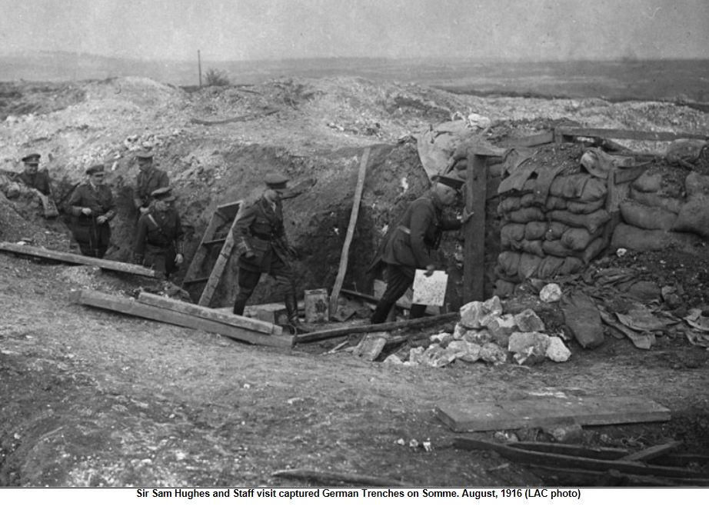
And here’s the second brigade diary for the day:
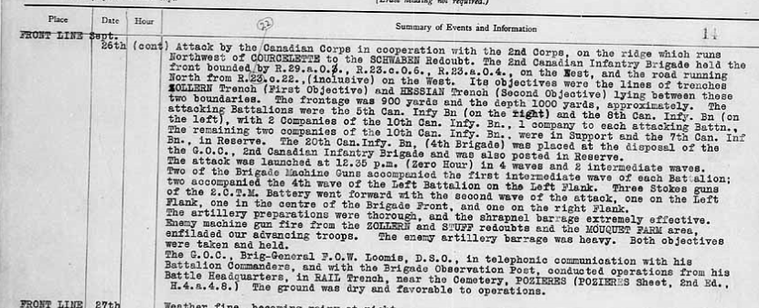
But the best war diary entry I ever read was the 5th Battalion diary for that day:

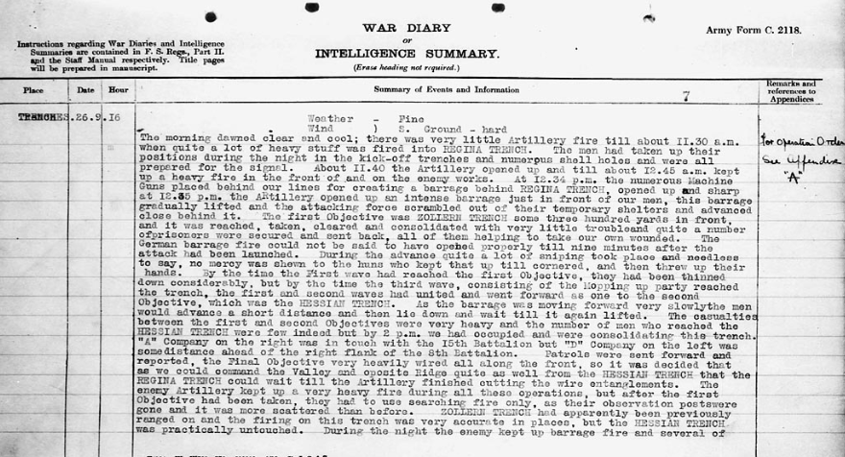

5th Battalion Diary for April 24, 25 and 28, 1916

Entry for April 24th

Enemy started a most intense bombardment on our front commending about 2 p.m. and kept it up till 6 p.m. utterly wiping out our front line. He used all calibre guns and trench mortars. Our own artillery replied most effectively, absolutely demolishing his trench system on HILL 60. After the bombardment had finished one of the enemy was noticed waving a white flag from the remnants of the trenches. The casualties were very light considering the intensity of the bombardment and the weakness of our trenches. Whole trenches were completely blown in and when the bombardment ceased our men were just holding small holes here and there. The morale of the men was excellent throughout it all. The Bttn was relieved by the 2nd Can. Bttn., the relief not being complete until 4:00 a.m.
Casualties: 11 men killed, 6 men missing, 51 men wounded.

Entry for April 25th

The bttn. did not get back to billets until 8 a.m. They slept all day. Corps commander sent a congratulatory wire to the Bttn on the operations of the 24th which read as follows: The Corps Commander wishes to most sincerely congratulate the Colonel Dyer and 5th Battalion on the splendid staunchness and resoluteness exhibited during the heavy German bombardment yesterday.

Entry for April 28th
The battalion was specially inspect the General Sir Douglas Haig in the afternoon. He sent the following message to them: “I am proud to have a Battalion of this description in my army and wish to thank you for the magnificent gallantry you have displayed.”

Division 1 Diary Entry for April 24^{th,}

Hostile artillery very active on the 24th.

During the morning the enemy threw several large Minenwerfer bombs int our trenches opposite HILL 60. Bombs were over three feet long and a foot in diameter. About 5 a.m. enemy’s Minenwerfers were active and appeared to be coming from behind HILL60. From 8 am the enemy’s trench mortars kept up an irregular fire until 2 p.m...the enemy then started shelling and put in over 100 shells, a large proportion of which were gas shells.

At 3:15 p.m. on the 24th the enemy opened fire on our front opposite HILL 60 with 77 mm. Guns, 4.1. Hors. And guns, Minerwerfers and small bombs. Barrage of fire was formed behind our front line and until 6 p.m. the bombardment was intense, large Trench Mortar bombs falling at the rate of ten a minute while heavy guns and howitzers also bombarded.

1st Battalion CMR: Diary for June 2nd ( Devastating First Day of Battle of Mount Sorrel – Day of Obliteration) re Andrew Mitchell

Battalion occupying Trenches 54 – 60.

8:30 AM. The Enemy commenced heavy bombardment which lasted until 1:15 PM.

1:15 PM Lt. Col. A.E. Shaw killed at Battn Hqrs during a determined stand made by him and about 80 others of the Battn., against enemy’s Troops who had succeeded in piercing our line to right of Trench 52 occupied by 4th CMR Battn. The company of this Battn. occupying the trenches on our right being completely destroyed by being blown up by one of enemy’s mines. After Col. Shaw was killed, Major Palmer took command and defended the position at BIGO ST. at Battn Hqrs until there was only two officers and eight other ranks remaining alive and unwounded. The Enemy having bombed the survivors to one end of the trench and having no ammunition or bombs to reply to the Enemy’s fire, he gave orders for remainder to get out if they could and retire to SP. 14 and hold on there. As far as it is known only one officer, Leightenant F.A. Hey and about four or five others were the only ones who arrived at this point which they found occupied by Leight. A.V. Evans and a few men with a Colt machine gun. This position was held by them until relieved, and has since remained in our possession. Out of 21 Officers and 671 Other Ranks who went in to trenches during this tour, 5 officers are reported as killed, 5 wounded and 10 missing, Other Ranks, total casualties 506, 135 returning.

7th Infantry Brigade Diary for September 15, 16 and 17 (re Richard Buckley) – Battle for Courcelette

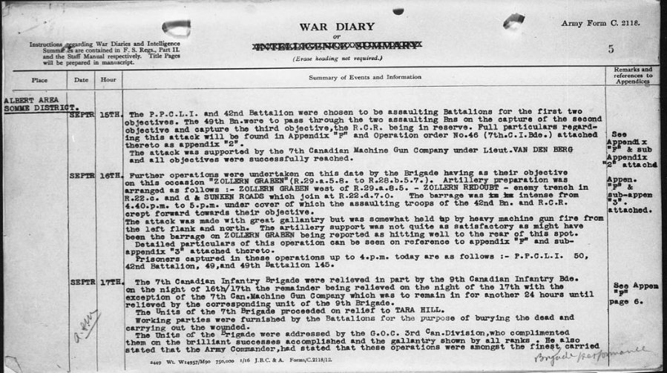
Battle of Thiepval Ridge (September 26th)

Here’s the Wikipedia description of the Thiepval Ridge assault actions of Wilfrid’s 1st Division:

The 1st Canadian Division attacked with two brigades. The right brigade with two battalions advanced 400 yards (370 m) to Sudbury Trench and resumed the advance at 1:00 p.m., reaching Kenora Trench [on the right which ran north-west back to Regina/Stuff Trench by 2:40 p.m.
The battalion on the left (the 5th) had been delayed and German bombers counter-attacked the flank and were repulsed. The left battalion had formed up in no man's land, to escape the German counter-barrage but had a harder fight to reach their objectives, taking until mid-afternoon to reach the second objective, which was just short of the ridge crest, linking with the left brigade later. The left brigade advanced with two reinforced battalions, which received machine-gun fire from the left flank but reached Zollern Trench, taking the western part after a delay. At 1:00 p.m., the advance resumed towards Hessian Trench, which was taken easily. Touch was gained with the right brigade but troops from the 11th Division on the left were not found. The Canadians bombed down Zollern Trench and built a barricade, as machine-gun fire forced a slight withdrawal from the left part of Hessian Trench, a defensive flank being thrown back from Hessian to Zollern Trench and dug in by 10:30 p.m..

Appendix: Venereal Disease Among the Canadians at Bramshott

Canadians were paid more than their British counterparts, and drink and women were affordable luxuries. Overspending and overindulging were common. Rates of venereal disease increased, and men diagnosed received a fine of a half-day’s pay for each day they were in hospital. They also had to give up their field allowance of 10 cents per day.

